UNITED STATES
SECURITIES AND EXCHANGE COMMISSION
Washington, D. C. 20549

FORM 8-K

CURRENT REPORT
Pursuant to Section 13 or 15(d)
of the Securities Exchange Act of 1934
Date of Report (Date of earliest event reported): August 6, 2026

Dana Incorporated
(Exact name of registrant as specified in its charter)

Delaware |  | 1-1063 |  | 26-1531856
(State or other jurisdiction  of incorporation) |  | (Commission  File Number) |  | (IRS Employer  Identification Number)
3939 Technology Drive, Maumee, Ohio 43537
(Address of principal executive offices) (Zip Code)
(419) 887-3000
(Registrant’s telephone number, including area code)

Check the appropriate box below if the Form 8-K filing is intended to simultaneously satisfy the filing obligation of the registrant under any of the following provisions:

☒ | Written communications pursuant to Rule 425 under the Securities Act (17 CFR 230.425)

☐ | Soliciting material pursuant to Rule 14a-12 under the Exchange Act (17 CFR 240.14a-12)

☐ | Pre-commencement communications pursuant to Rule 14d-2(b) under the Exchange Act (17 CFR 240.14d-2(b))

☐ | Pre-commencement communications pursuant to Rule 13e-4(c) under the Exchange Act (17 CFR 240.13e-4(c))

Title of Each Class |  | Trading  Symbol |  | Name of Each Exchange  on which Registered
Common Stock, $0.01 par value |  | DAN |  | New York Stock Exchange
Indicate by check mark whether the registrant is an emerging growth company as defined in Rule 405 of the Securities Act of 1933 (§230.405 of this chapter) or Rule 12b-2 of the Securities Exchange Act of 1934 (§240.12b-2 of this chapter).
Emerging growth company ☐
If an emerging growth company, indicate by check mark if the registrant has elected not to use the extended transition period for complying with any new or revised financial accounting standards provided pursuant to Section 13(a) of the Exchange Act. ☐

Items 2.02 and 7.01 Results of Operations and Financial Condition and Regulation FD Disclosure
Dana Incorporated today issued a news release announcing its results for the quarter ended June 30, 2026. A copy of the press release is attached hereto as Exhibit 99.1.
The information in this report is being “furnished” and shall not be deemed “filed” for the purposes of Section 18 of the Securities Exchange Act of 1934, as amended, is not subject to the liabilities of that section and is not deemed incorporated by reference in any filing under the Securities Act of 1933, as amended, or the Securities Exchange Act of 1934, as amended, except as shall be expressly set forth by specific reference in such a filing.

Item 9.01. | Financial Statements and Exhibits.
(d) Exhibits. The following item is furnished with this report.

Exhibit  No. |  | Description
99.1 |  | Dana Incorporated Press Release dated August 6, 2026
104 |  | Cover Page Interactive Data File (embedded within the Inline XBRL

2

SIGNATURES
Pursuant to the requirements of the Securities Exchange Act of 1934, the registrant has duly caused this report to be signed on its behalf by the undersigned hereunto duly authorized.

 |  |  |  | DANA INCORPORATED
Date: August 6, 2026 |  |  |  | By: |  | /s/ Douglas H. Liedberg
 |  |  |  | Name: |  | Douglas H. Liedberg
 |  |  |  | Title: |  | Senior Vice President, Chief Legal and  Human Resources Officer and Secretary

3

Exhibit 99.1


Dana Incorporated Reports Strong Second-Quarter Results; Increases Full-Year Guidance; Restarts Share Repurchase Program
Second-Quarter Highlights:

 |  |  | Sales of $2.0 billion, up 4 percent versus the second quarter of 2025

 |  |  | Adjusted EBITDA of $207 million; $60 million higher than second quarter of 2025

 |  |  | 10.3 percent adjusted EBITDA margin; 270 basis points higher than prior year

 |  |  | Achieved $19 million in additional cost savings

 |  |  | Repurchased 1.2 million shares, returning $44 million to shareholders

 |  |  | Year-to-date shareholder returns of $169 million

 |  |  | Planning an additional ~$200 million of repurchases in 2026

 |  |  | Eaton Mobility transaction remains on track for first-quarter of 2027 close
MAUMEE, Ohio, August 6, 2026 – Dana Incorporated (NYSE: DAN) today announced its second-quarter 2026 financial results, delivering strong performance, expanding margins, and increasing its full-year outlook.
“Dana continues to execute our strategy with discipline and consistency, delivering another quarter of strong margin expansion while advancing our long-term growth initiatives,” said Byron Foster, Chief Executive Officer. “Our performance reflects the benefits of pricing actions, operational improvements, and continued cost-savings initiatives, while demand has improved across our end markets. We have also announced that we are restarting our share repurchase program to continue until the closing of the Eaton Mobility transaction and remain committed to returning meaningful capital to shareholders. Combined with the strategic value creation opportunities associated with the planned Eaton Mobility transaction, we believe Dana is well positioned to deliver sustainable growth and increased shareholder value.”
Sales in the second quarter of 2026 totaled $2.01 billion, compared with $1.94 billion in the same period of 2025. The increase was primarily driven by higher demand across end markets, pricing actions, and favorable currency translation.
Adjusted EBITDA for the second quarter was $207 million, representing a 10.3 percent margin, compared with $147 million, or 7.6 percent, for the same period in 2025. Cost-savings actions, operational efficiency improvements, and pricing initiatives were the primary drivers of the improvement.
Net income from continuing operations was $11 million in the second quarter of 2026, compared with a loss of $12 million, in the second quarter of 2025. Diluted earnings per share from continuing operations were $0.06 in the second quarter of 2026 compared to a loss of $0.11 last year. The second quarter of 2026 benefited from significantly improved operating performance, reflecting cost-reduction initiatives, material cost savings, operational improvements, and lower net interest expense associated with debt repayment following the Off-Highway divestiture.
Adjusted net income was $21 million in the second quarter of 2026, compared with $4 million in the prior-year period, while diluted adjusted earnings per share increased to $0.19 from $0.03
Operating cash flow in the second quarter of 2026 was $109 million, compared with $32 million in the same period of 2025. Adjusted free cash flow was $68 million, compared with a use of $7 million in the second quarter of 2025. Higher profitability, lower one-time costs, lower taxes, and improved working capital performance more than offset the loss of discontinued operations following the Off-Highway divestiture.
Dana today announced the restart of its share repurchase program, which had been suspended following the announcement of the proposed Eaton Mobility transaction. During the second quarter, the company repurchased approximately 1.2 million shares, returning $44 million to shareholders. Year-to-date, Dana has returned $169 million to shareholders and expects to repurchase an additional $200 million of shares before the end of 2026. Dana and Eaton are evaluating the possibility of additional share repurchases following the closing of the transaction.

1

Dana also has continued to make progress on its announced combination with Eaton’s Mobility business. The companies now expect to utilize a split-off structure for the transaction, which is intended to be tax-free to shareholders and provides for an orderly distribution of shares. The transaction remains on track to close during the first quarter of 2027, subject to approval by Dana shareholders, receipt of regulatory approvals, and customary closing conditions.
“The planned combination with Eaton Mobility remains a highly strategic opportunity that accelerates our Dana 2030 objectives and creates a stronger, more diversified global powertrain leader,” Foster added. “At the same time, we remain focused on executing the initiatives within our control—improving our cost structure, enhancing manufacturing performance, generating strong cash flow, and returning capital to shareholders.”
Dana has revised its full-year financial guidance upward, increasing its sales outlook by approximately $225 million and its adjusted EBITDA outlook by approximately $25 million. The higher guidance reflects stronger market conditions, favorable commercial-vehicle demand, ongoing cost-reduction actions, and favorable currency translation.
Revised 2026 Financial Targets

 |  | Revised Guidance
Sales |  | $7.65 to $7.85 billion
Adjusted EBITDA |  | $800 to $850 million
Implied adjusted EBITDA margin |  | ~10.6%
Diluted Adjusted EPS |  | $1.75 to $2.25
Adjusted free cash flow |  | $275 to $375 million
Dana to Host Conference Call at 9 a.m. Thursday, August 6
Dana will discuss its second quarter 2026 results in a conference call at 9 a.m. EDT on Thursday, August 6. The conference call can be accessed by telephone from both domestic and international locations using the information provided below:
Conference ID: 9943139
Participant Toll-Free Dial-In Number: (888) 440-5873
Participant Toll Dial-In Number: +1 (646) 960-0319
Audio streaming and slides will be available online via a link provided on the Dana investor website: www.dana.com/investors. Phone registration will be available beginning at 8:30 a.m. EDT.
A webcast replay can be accessed via Dana’s investor website following the call.
Cautionary Notes on Forward-Looking Statements
This communication includes “forward-looking statements” within the meaning of the federal securities laws, including Section 27A of the Securities Act of 1933, as amended (the “Securities Act”), and Section 21E of the Securities Exchange Act of 1934, as amended by the Private Securities Litigation Reform Act of 1995, including statements regarding the proposed transaction between Eaton Corporation plc (“Eaton”), Dana Incorporated (“Dana”) and Mobility (USA) Corporation (“SpinCo”), as well as statements regarding Dana’s business, financial condition and results of operations more generally. These forward-looking statements generally are identified by the words “believe,” “project,” “expect,” “anticipate,” “estimate,” “forecast,” “outlook,” “target,” “endeavor,” “seek,” “predict,” “intend,” “strategy,” “plan,” “may,” “could,” “should,” “will,” “would,” “potential,” “continue,” “ongoing,” or the negative thereof or variations thereon or similar terminology generally intended to identify forward-looking statements. All statements, other than historical

2

facts, including, but not limited to, statements regarding Dana’s current expectations, estimates and projections about its industry and business, the expected timing and structure of the proposed transaction and financing of the transaction, the ability of the parties to complete the proposed transaction, the expected benefits of the proposed transaction, including future financial and operating results and strategic and synergistic benefits, the tax consequences of the proposed transaction and the combined company’s plans, objectives, expectations and intentions, legal, economic and regulatory conditions, and any assumptions underlying any of the foregoing, are forward-looking statements.
These forward-looking statements are based on Dana’s current expectations and are subject to risks and uncertainties and are not guarantees of future results. Should one or more of these risks or uncertainties materialize, or should underlying assumptions prove incorrect, actual results may vary materially from those indicated or anticipated by such forward-looking statements. The inclusion of such statements should not be regarded as a representation that such plans, estimates or expectations will be achieved. Important factors that could cause actual results to differ materially from such plans, estimates or expectations include, among others, the ability to complete the proposed transaction on the timeframe or on the terms currently anticipated or at all, including due to a failure to obtain requisite stockholder and/or regulatory approvals; risks related to difficulties, inabilities or delays in integrating the businesses of Dana and SpinCo; the ability to realize the anticipated benefits of the proposed transaction, including estimated combined EBITDA, estimated combined revenue and estimated run-rate cost synergies; potential impact of the proposed transaction on Dana’s stock price; restrictions on the conduct of Dana’s business prior to and after closing and on its ability to pursue alternatives to the proposed transaction; the possibility that the proposed transaction may be more expensive to complete than anticipated, including as a result of unexpected factors or events, or unforeseen or unknown liabilities; the ability of the combined company to implement its business strategy; the inability of the combined company to retain and hire key personnel; the occurrence of any event that could give rise to termination of the proposed transaction; the risk that stockholder litigation in connection with the proposed transaction or other litigation, settlements or investigations may affect the timing or occurrence of the proposed transaction or result in significant costs of defense, indemnification and liability; risks relating to the ability to obtain financing for the transaction upon acceptable terms or at all; evolving legal, regulatory and tax regimes; changes in general economic and/or industry specific conditions; global economic repercussions related to U.S. and global inflationary pressures and potential recessionary concerns; the risks that the anticipated tax treatment of the proposed transaction is not obtained; the risk of greater than expected difficulty in separating the business of SpinCo from the other businesses of Eaton; risks related to the disruption of management time from ongoing business operations due to the pendency of the proposed transaction, or other effects of the pendency of the proposed transaction on the relationship of any of the parties to the transaction with their employees, customers, suppliers or other counterparties; and other risk factors detailed from time to time in Dana’s reports filed with the Securities and Exchange Commission (the “SEC”), including Dana’s annual reports on Form 10-K, quarterly reports on Form 10-Q, current reports on Form 8-K and other documents filed with the SEC, including documents that will be filed with the SEC in connection with the proposed transaction. The foregoing list of important factors is not exclusive.
Any forward-looking statements speak only as of the date of this communication. Dana does not undertake, and expressly disclaims, any obligation to update any forward-looking statements, whether as a result of new information or development, future events or otherwise, except as required by law. Readers are cautioned not to place undue reliance on any of these forward-looking statements.
It should also be noted that projected financial information for the combined company is based on management’s estimates, assumptions and projections and has not been prepared in conformance with the applicable accounting requirements of Regulation S-X relating to pro forma financial information, and the required pro forma adjustments have not been applied and are not reflected therein. None of this information should be considered in isolation from, or as a substitute for, the historical financial statements of Dana or SpinCo.
Important Information About the Transaction and Where to Find It

3

In connection with the proposed transaction, SpinCo may file with the SEC an information statement on Form 10 (“Form 10”) or a registration statement on Form S-1/S-4 (the “Form S-1/S-4”) that constitutes a prospectus with respect to the shares of common stock, par value $0.01 per share, of SpinCo (the “SpinCo shares”) to be issued to Eaton shareholders in the proposed exchange offer (the “prospectus/offer to exchange”). Eaton may also file with the SEC a tender offer statement (the “Schedule TO”) with respect to the offer by Eaton to exchange all SpinCo shares for ordinary shares, par value $0.01 per share, of Eaton that are validly tendered and not properly withdrawn prior to the expiration of the exchange offer (if any). In addition, SpinCo intends to file with the SEC a registration statement on Form S-4 (the “Form S-4”) that will include a proxy statement of Dana and that also constitutes a prospectus of SpinCo with respect to the SpinCo shares to be issued in the proposed merger (the “proxy statement/prospectus”). Each of Eaton, SpinCo and Dana may also file other relevant documents with the SEC regarding the proposed transaction.
This document is not a substitute for the Form 10, Form S-1/S-4, Schedule TO, Form S-4, prospectus/offer to exchange, proxy statement/prospectus or any other document that Eaton, SpinCo or Dana may file with the SEC. INVESTORS AND SECURITY HOLDERS ARE URGED TO READ THE REGISTRATION STATEMENTS, THE SCHEDULE TO; THE PROSPECTUS/OFFER TO EXCHANGE, THE PROXY STATEMENT/PROSPECTUS AND ANY OTHER RELEVANT DOCUMENTS THAT MAY BE FILED WITH THE SEC, AS WELL AS ANY AMENDMENTS OR SUPPLEMENTS TO THESE DOCUMENTS, CAREFULLY AND IN THEIR ENTIRETY IF AND WHEN THEY BECOME AVAILABLE BECAUSE THEY CONTAIN OR WILL CONTAIN IMPORTANT INFORMATION ABOUT EATON, DANA, SPINCO AND THE PROPOSED TRANSACTION. Investors and security holders will be able to obtain free copies of the Form 10, Form S-1/S-4, Schedule TO, Form S-4, the prospectus/offer to exchange and the proxy statement/prospectus (if and when available) and other documents containing important information about Eaton, Dana and SpinCo and the proposed transaction, once such documents are filed with the SEC through the website maintained by the SEC at http://www.sec.gov. Copies of the documents filed with, or furnished to, the SEC by Eaton and SpinCo will be available free of charge on Eaton’s website at https://www.eaton.com/us/en-us/company/investor-relations.html. Copies of the documents filed with, or furnished to, the SEC by Dana will be available free of charge on Dana’s website at https://danaincorporated.gcs-web.com/. The information included on, or accessible through, Eaton or Dana’s website is not incorporated by reference into this communication.
Participants in the Solicitation
Eaton, Dana, SpinCo and certain of their respective directors and executive officers may be deemed to be participants in the solicitation of proxies in respect of the proposed transaction. Information about the directors and executive officers of Eaton, including a description of their direct or indirect interests, by security holdings or otherwise, is set forth in Eaton’s proxy statement for its 2026 Annual General Meeting of Shareholders, which was filed with the SEC on March 13, 2026. Information about the directors and executive officers of Dana, including a description of their direct or indirect interests, by security holdings or otherwise, is set forth in Dana’s proxy statement for its 2026 Annual Meeting of Stockholders, which was filed with the SEC on March 13, 2026. Other information regarding the participants in the proxy solicitation and a description of their direct and indirect interests, by security holdings or otherwise, will be contained in the Form S-4 and the proxy statement/prospectus and other relevant materials to be filed with the SEC regarding the proposed transaction when such materials become available. Investors should read the Form 10, Form S-1/S-4, Schedule TO, Form S-4, the prospectus/offer to exchange and the proxy statement/prospectus carefully if and when available before making any voting or investment decisions. You may obtain free copies of these documents from Eaton or Dana using the sources indicated above.
No Offer or Solicitation
This communication is not intended to and shall not constitute an offer to sell or the solicitation of an offer to sell or the solicitation of an offer to buy or exchange any securities, or a solicitation of any vote or approval, nor shall there be any sale of securities in any jurisdiction in which such offer, solicitation, sale or exchange would be unlawful prior to registration or qualification under the securities laws of any such jurisdiction. No offer of securities shall be made except by means of a prospectus meeting the requirements of Section 10 of the Securities Act or in a transaction exempt from the registration requirements of the Securities Act.
Note Regarding Use of Non-GAAP Financial Measures
In addition to the financial measures presented in accordance with U.S. generally accepted accounting principles (“U.S. GAAP”), this communication includes certain non-GAAP financial measures (collectively, the “Non-GAAP Measures”), such as adjusted EBITDA, adjusted EBITDA margin, adjusted net income (loss) attributable to the parent company, diluted adjusted EPS, adjusted free cash flow and adjusted free cash flow margin.

4

Adjusted EBITDA is a non-GAAP financial measure which we have defined as net income (loss) before interest, income taxes, depreciation, amortization, equity grant expense, restructuring expense, non-service cost components of pension and other postretirement benefit costs and other adjustments not related to our core operations (gain/loss on debt extinguishment, pension settlements, divestitures, impairment, etc.). Adjusted EBITDA is a measure of our ability to maintain and continue to invest in our operations and provide shareholder returns. We use adjusted EBITDA in assessing the effectiveness of our business strategies, evaluating and pricing potential acquisitions and as a factor in making incentive compensation decisions. In addition to its use by management, we also believe adjusted EBITDA is a measure widely used by securities analysts, investors and others to evaluate financial performance of our company relative to other Tier 1 automotive suppliers.
Adjusted net income (loss) attributable to the parent company is a non-GAAP financial measure which we have defined as net income (loss) attributable to the parent company, excluding any discrete income tax items, restructuring charges, amortization expense and other adjustments not related to our core operations (as used in adjusted EBITDA), net of any associated income tax effects. This measure is considered useful for purposes of providing investors, analysts and other interested parties with an indicator of ongoing financial performance that provides enhanced comparability to net income (loss) attributable to the parent company reported by other companies. Adjusted net income (loss) attributable to the parent company is neither intended to represent nor be an alternative measure to net income (loss) attributable to the parent company reported in accordance with GAAP.
Diluted adjusted EPS is a non-GAAP financial measure which we have defined as adjusted net income (loss) attributable to the parent company divided by adjusted diluted shares. We define adjusted diluted shares as diluted shares as determined in accordance with GAAP based on adjusted net income (loss) attributable to the parent company. This measure is considered useful for purposes of providing investors, analysts and other interested parties with an indicator of ongoing financial performance that provides enhanced comparability to EPS reported by other companies. Diluted adjusted EPS is neither intended to represent nor be an alternative measure to diluted EPS reported in accordance with GAAP.
Adjusted free cash flow is a non-GAAP financial measure which we have defined as net cash provided by (used in) operating activities less purchases of property, plant and equipment plus proceeds from sale of property, plant and equipment plus cash paid for Off-Highway business divestiture related activities. We believe adjusted free cash flow is useful to investors in evaluating the operational cash flow of the company inclusive of the spending required to maintain the operations. Adjusted free cash flow is not intended to represent nor be an alternative to the measure of net cash provided by (used in) operating activities reported in accordance with GAAP.
These Non-GAAP Measures should not be used in isolation or as a substitute or alternative to results determined in accordance with U.S. GAAP. In addition, Dana’s and Eaton’s definitions of these Non-GAAP Measures may not be comparable to similarly titled non-GAAP financial measures reported by other companies. A reconciliation of these Non-GAAP Measures to the most directly comparable financial measures calculated and reported in accordance with U.S. GAAP can be found in Dana’s filings with the SEC and/or the accompanying financial information, except for financial guidance and other forward-looking information since such a reconciliation is not practicable without unreasonable effort as Dana is unable to reasonably forecast certain amounts that are necessary for such reconciliation. We have not provided a reconciliation of our adjusted EBITDA outlook to the most comparable GAAP measures of net income (loss). Providing net income (loss) guidance is potentially misleading and not practical given the difficulty of projecting event-driven transactional and other non-core operating items that are included in net income (loss), including restructuring actions, asset impairments and certain income tax adjustments. The accompanying reconciliations of these non-GAAP measures with the most comparable GAAP measures for the historical periods presented are indicative of the reconciliations that will be prepared upon completion of the periods covered by the non-GAAP guidance.

5

About Dana Incorporated
Dana Incorporated (NYSE: DAN) is a global leader in the design and manufacture of highly efficient propulsion solutions for the light- and commercial-vehicle markets. Guided by its vision to be the world’s best powertrain company, Dana delivers advanced conventional and clean-energy technologies that help customers improve the performance, efficiency, and durability of their vehicles. The company supplies leading vehicle manufacturers and related aftermarkets with industry-defining drive systems, electrodynamic technologies, and thermal and sealing solutions.
Headquartered in Maumee, Ohio, USA, Dana reported sales of $7.5 billion in 2025. With a history dating to 1904, the company employs 27,000 people in 24 countries across six continents. Learn more at dana.com
###
Contact: Craig Barber
+1-419-887-5166
craig.barber@dana.com

6

DANA INCORPORATED
Consolidated Statement of Operations (Unaudited)
For the Three Months Ended June 30, 2026 and 2025

 |  | Three Months Ended
(In millions, except per share amounts) |  | June 30,
 |  | 2026 |  |  |  | 2025
Net sales |  | $ | 2,010 |  |  | $ | 1,935
Costs and expenses
Cost of sales |  |  | 1,800 |  |  |  | 1,797
Selling, general and administrative expenses |  |  | 104 |  |  |  | 99
Amortization of intangibles |  |  | 1 |  |  |  | 2
Restructuring charges, net |  |  | 9 |  |  |  | 11
Other income (expense), net |  |  | (20 | ) |  |  | (10 | )
Earnings from continuing operations before interest and income taxes |  |  | 76 |  |  |  | 16
Interest income |  |  | 4 |  |  |  | 3
Interest expense |  |  | 21 |  |  |  | 44
Earnings (loss) from continuing operations before income taxes |  |  | 59 |  |  |  | (25 | )
Income tax expense |  |  | 54 |  |  |  | 10
Equity in earnings of affiliates |  |  | 6 |  |  |  | 23
Net income (loss) from continuing operations |  |  | 11 |  |  |  | (12 | )
Net income (loss) from discontinued operations |  |  | (11 | ) |  |  | 43
Net income |  |  | — |  |  |  | 31
Less: Noncontrolling interests net income from continuing operations |  |  | 5 |  |  |  | 4
Net income (loss) attributable to the parent company |  | $ | (5 | ) |  | $ | 27
Net income (loss) per share available to common stockholders
Basic earnings (loss) per share from continuing operations |  | $ | 0.06 |  |  | $ | (0.11 | )
Basic earnings (loss) per share from discontinued operations |  |  | (0.11 | ) |  |  | 0.30
Basic earnings (loss) per share |  | $ | (0.05 | ) |  | $ | 0.19
Diluted earnings (loss) per share from continuing operations |  | $ | 0.05 |  |  | $ | (0.11 | )
Diluted earnings (loss) per share from discontinued operations |  |  | (0.10 | ) |  |  | 0.30
Diluted earnings (loss) per share |  | $ | (0.05 | ) |  | $ | 0.19
Weighted-average shares outstanding - Basic |  |  | 108.1 |  |  |  | 143.8
Weighted-average shares outstanding - Diluted |  |  | 109.5 |  |  |  | 143.8

7

DANA INCORPORATED
Consolidated Statement of Operations (Unaudited)
For the Six Months Ended June 30, 2026 and 2025

 |  | Six Months Ended
(In millions, except per share amounts) |  | June 30,
 |  | 2026 |  |  |  | 2025
Net sales |  | $ | 3,878 |  |  | $ | 3,716
Costs and expenses
Cost of sales |  |  | 3,499 |  |  |  | 3,460
Selling, general and administrative expenses |  |  | 206 |  |  |  | 204
Amortization of intangibles |  |  | 3 |  |  |  | 4
Restructuring charges, net |  |  | 15 |  |  |  | 13
Other income (expense), net |  |  | (60 | ) |  |  | (11 | )
Earnings from continuing operations before interest and income taxes |  |  | 95 |  |  |  | 24
Loss on extinguishment of debt |  |  | (7 | ) |  |  | —
Interest income |  |  | 10 |  |  |  | 5
Interest expense |  |  | 43 |  |  |  | 83
Earnings (loss) from continuing operations before income taxes |  |  | 55 |  |  |  | (54 | )
Income tax expense |  |  | 68 |  |  |  | —
Equity in earnings of affiliates |  |  | 9 |  |  |  | 25
Net loss from continuing operations |  |  | (4 | ) |  |  | (29 | )
Net income from discontinued operations |  |  | 1,095 |  |  |  | 90
Net income |  |  | 1,091 |  |  |  | 61
Less: Noncontrolling interests net income from continuing operations |  |  | 9 |  |  |  | 9
Net income attributable to the parent company |  | $ | 1,082 |  |  | $ | 52
Net income (loss) per share available to common stockholders
Basic loss per share from continuing operations |  | $ | (0.12 | ) |  | $ | (0.26 | )
Basic earnings per share from discontinued operations |  |  | 10.05 |  |  |  | 0.62
Basic earnings per share |  | $ | 9.93 |  |  | $ | 0.36
Diluted loss per share from continuing operations |  | $ | (0.12 | ) |  | $ | (0.26 | )
Diluted earnings per share from discontinued operations |  |  | 10.05 |  |  |  | 0.62
Diluted earnings per share |  | $ | 9.93 |  |  | $ | 0.36
Weighted-average shares outstanding - Basic |  |  | 109.0 |  |  |  | 144.7
Weighted-average shares outstanding - Diluted |  |  | 109.0 |  |  |  | 144.7

8

DANA INCORPORATED
Consolidated Statement of Comprehensive Income (Unaudited)
For the Three Months Ended June 30, 2026 and 2025

 |  | Three Months Ended
(In millions) |  | June 30,
 |  | 2026 |  |  |  | 2025
Net income (loss) from continuing operations |  | $ | 11 |  |  | $ | (12 | )
Other comprehensive income (loss) from continuing operations, net of tax:
Currency translation adjustments |  |  | 21 |  |  |  | 35
Hedging gains and losses |  |  | (2 | ) |  |  | 23
Other comprehensive income from continuing operations |  |  | 19 |  |  |  | 58
Total comprehensive income from continuing operations |  |  | 30 |  |  |  | 46
Net income (loss) from discontinued operations |  |  | (11 | ) |  |  | 43
Other comprehensive income (loss) from discontinued operations, net of tax:
Currency translation adjustments |  |  | — |  |  |  | 6
Hedging gains and losses |  |  | — |  |  |  | 1
Other comprehensive income from discontinued operations |  |  | — |  |  |  | 7
Total comprehensive income (loss) from discontinued operations |  |  | (11 | ) |  |  | 50
Total comprehensive income |  |  | 19 |  |  |  | 96
Less: Comprehensive income from continuing operations attributable to noncontrolling interests |  |  | (5 | ) |  |  | (6 | )
Comprehensive income attributable to the parent company |  | $ | 14 |  |  | $ | 90

9

DANA INCORPORATED
Consolidated Statement of Comprehensive Income (Unaudited)
For the Six Months Ended June 30, 2026 and 2025

 |  | Six Months Ended
(In millions) |  | June 30,
 |  | 2026 |  |  |  | 2025
Net loss from continuing operations |  | $ | (4 | ) |  | $ | (29 | )
Other comprehensive income (loss) from continuing operations, net of tax:
Currency translation adjustments |  |  | 23 |  |  |  | 47
Hedging gains and losses |  |  | (6 | ) |  |  | 41
Defined benefit plans |  |  | (1 | ) |  |  | —
Other comprehensive income from continuing operations |  |  | 16 |  |  |  | 88
Total comprehensive income from continuing operations |  |  | 12 |  |  |  | 59
Net income from discontinued operations |  |  | 1,095 |  |  |  | 90
Other comprehensive income (loss) from discontinued operations, net of tax:
Currency translation adjustments |  |  | 179 |  |  |  | 8
Hedging gains and losses |  |  | — |  |  |  | 1
Other comprehensive income from discontinued operations |  |  | 179 |  |  |  | 9
Total comprehensive income from discontinued operations |  |  | 1,274 |  |  |  | 99
Total comprehensive income |  |  | 1,286 |  |  |  | 158
Less: Comprehensive income from continuing operations attributable to noncontrolling interests |  |  | (9 | ) |  |  | (11 | )
Comprehensive income attributable to the parent company |  | $ | 1,277 |  |  | $ | 147

10

DANA INCORPORATED
Consolidated Balance Sheet (Unaudited)
As of June 30, 2026 and December 31, 2025

(In millions, except share and per share amounts) |  | June 30, |  |  |  | December 31,
 |  | 2026 |  |  |  | 2025
Assets
Current assets
Cash and cash equivalents |  | $ | 331 |  |  | $ | 469
Accounts receivable
Trade, less allowance for doubtful accounts of $12 in 2026 and $15 in 2025 |  |  | 1,287 |  |  |  | 987
Other |  |  | 286 |  |  |  | 254
Inventories |  |  | 980 |  |  |  | 1,015
Other current assets |  |  | 285 |  |  |  | 114
Current assets of disposal group held for sale |  |  | 36 |  |  |  | 1,029
Total current assets |  |  | 3,205 |  |  |  | 3,868
Intangibles |  |  | 58 |  |  |  | 71
Deferred tax assets |  |  | 495 |  |  |  | 534
Other noncurrent assets |  |  | 114 |  |  |  | 102
Investments in affiliates |  |  | 112 |  |  |  | 102
Operating lease assets |  |  | 166 |  |  |  | 305
Property, plant and equipment, net |  |  | 1,942 |  |  |  | 1,872
Noncurrent assets of disposal group held for sale |  |  | 21 |  |  |  | 954
Total assets |  | $ | 6,113 |  |  | $ | 7,808
Liabilities and equity
Current liabilities
Short-term debt |  | $ | — |  |  | $ | 615
Current portion of long-term debt |  |  | 27 |  |  |  | 30
Accounts payable |  |  | 1,301 |  |  |  | 1,154
Accrued payroll and employee benefits |  |  | 170 |  |  |  | 210
Taxes on income |  |  | 78 |  |  |  | 75
Current portion of operating lease liabilities |  |  | 34 |  |  |  | 41
Other accrued liabilities |  |  | 532 |  |  |  | 495
Current liabilities of disposal group held for sale |  |  | 14 |  |  |  | 688
Total current liabilities |  |  | 2,156 |  |  |  | 3,308
Long-term debt, less debt issuance costs of $8 in 2026 and $16 in 2025 |  |  | 1,317 |  |  |  | 2,566
Noncurrent operating lease liabilities |  |  | 125 |  |  |  | 266
Pension and postretirement obligations |  |  | 241 |  |  |  | 249
Other noncurrent liabilities |  |  | 291 |  |  |  | 337
Noncurrent liabilities of disposal group held for sale |  |  | — |  |  |  | 183
Total liabilities |  |  | 4,130 |  |  |  | 6,909
Commitments and contingencies
Parent company stockholders’ equity
Preferred stock, 50,000,000 shares authorized, $0.01 par value, no shares outstanding |  |  | — |  |  |  | —
Common stock, 450,000,000 shares authorized, $0.01 par value, 107,576,158 and 112,284,138 shares outstanding |  |  | 1 |  |  |  | 1
Additional paid-in capital |  |  | 1,518 |  |  |  | 1,671
Retained earnings |  |  | 1,290 |  |  |  | 235
Treasury stock, at cost (2,508,917 and 1,944,700 shares) |  |  | (52 | ) |  |  | (35 | )
Accumulated other comprehensive loss |  |  | (837 | ) |  |  | (1,032 | )
Total parent company stockholders’ equity |  |  | 1,920 |  |  |  | 840
Noncontrolling interests |  |  | 63 |  |  |  | 59
Total equity |  |  | 1,983 |  |  |  | 899
Total liabilities and equity |  | $ | 6,113 |  |  | $ | 7,808

11

DANA INCORPORATED
Consolidated Statement of Cash Flows (Unaudited)
For the Three Months Ended June 30, 2026 and 2025

 |  | Three Months Ended
(In millions) |  | June 30,
 |  | 2026 |  |  |  | 2025
Operating activities
Net income |  | $ | — |  |  | $ | 31
Less: Net income (loss) from discontinued operations |  |  | (11 | ) |  |  | 43
Net income (loss) from continuing operations |  |  | 11 |  |  |  | (12 | )
Depreciation |  |  | 82 |  |  |  | 89
Amortization |  |  | 2 |  |  |  | 3
Amortization of deferred financings charges |  |  | 10 |  |  |  | 2
Earnings of affiliates, net of dividends received |  |  | (5 | ) |  |  | (23 | )
Stock compensation expense |  |  | 8 |  |  |  | 10
Deferred income taxes |  |  | 19 |  |  |  | (8 | )
Pension expense, net |  |  | 1 |  |  |  | 1
Change in working capital |  |  | 31 |  |  |  | 216
Change in other noncurrent assets and liabilities |  |  | (34 | ) |  |  | (10 | )
Loss on divestiture of ownership interests |  |  | — |  |  |  | 7
Noncash electric vehicle program termination charges |  |  | 7 |  |  |  | —
Other, net |  |  | (8 | ) |  |  | 59
Net cash provided by operating activities from continuing operations |  |  | 124 |  |  |  | 334
Net cash used in operating activities from discontinued operations |  |  | (15 | ) |  |  | (302 | )
Net cash provided by operating activities |  |  | 109 |  |  |  | 32
Investing activities
Purchases of property, plant and equipment |  |  | (142 | ) |  |  | (37 | )
Proceeds from sale of property, plant and equipment |  |  | 1 |  |  |  | —
Proceeds from sales of investments |  |  | 1 |  |  |  | 57
Settlements of undesignated derivatives |  |  | (2 | ) |  |  | (4 | )
Other, net |  |  | (1 | ) |  |  | 3
Net cash provided by (used in) investing activities from continuing operations |  |  | (143 | ) |  |  | 19
Net cash used in investing activities from discontinued operations |  |  | (35 | ) |  |  | (14 | )
Net cash provided by (used in) investing activities |  |  | (178 | ) |  |  | 5
Financing activities
Net change in short-term debt |  |  | (3 | ) |  |  | 401
Repayment of long-term debt |  |  | (8 | ) |  |  | (206 | )
Dividends paid to common stockholders |  |  | (13 | ) |  |  | (14 | )
Repurchases of common stock |  |  | (44 | ) |  |  | (257 | )
Distributions to noncontrolling interests |  |  | (1 | ) |  |  | (2 | )
Swap settlements |  |  | — |  |  |  | (8 | )
Other, net |  |  | (7 | ) |  |  | (8 | )
Net cash used in financing activities |  |  | (76 | ) |  |  | (94 | )
Net decrease in cash, cash equivalents and restricted cash |  |  | (145 | ) |  |  | (57 | )
Cash, cash equivalents and restricted cash - beginning of period |  |  | 492 |  |  |  | 523
Effect of exchange rate changes on cash balances |  |  | 2 |  |  |  | 35
Cash, cash equivalents and restricted cash - end of period |  | $ | 349 |  |  | $ | 501

12

DANA INCORPORATED
Consolidated Statement of Cash Flows (Unaudited)
For the Six Months Ended June 30, 2026 and 2025

(In millions) |  | Six Months Ended  June 30,
 |  | 2026 |  |  |  | 2025
Operating activities
Net income |  | $ | 1,091 |  |  | $ | 61
Less: Net income from discontinued operations |  |  | 1,095 |  |  |  | 90
Net loss from continuing operations |  |  | (4 | ) |  |  | (29 | )
Depreciation |  |  | 166 |  |  |  | 171
Amortization |  |  | 5 |  |  |  | 6
Amortization of deferred financings charges |  |  | 2 |  |  |  | 3
Earnings of affiliates, net of dividends received |  |  | (8 | ) |  |  | (25 | )
Stock compensation expense |  |  | 19 |  |  |  | 23
Deferred income taxes |  |  | 30 |  |  |  | (26 | )
Pension expense, net |  |  | (4 | ) |  |  | —
Change in working capital |  |  | (221 | ) |  |  | (202 | )
Change in other noncurrent assets and liabilities |  |  | (23 | ) |  |  | (13 | )
Loss on divestiture of ownership interests |  |  | 8 |  |  |  | 7
Noncash electric vehicle program termination charges |  |  | 59 |  |  |  | —
Other, net |  |  | (39 | ) |  |  | 54
Net cash used in operating activities from continuing operations |  |  | (10 | ) |  |  | (31 | )
Net cash provided by (used in) operating activities from discontinued operations |  |  | (76 | ) |  |  | 26
Net cash used in operating activities |  |  | (86 | ) |  |  | (5 | )
Investing activities
Purchases of property, plant and equipment |  |  | (204 | ) |  |  | (104 | )
Proceeds from sale of property, plant and equipment |  |  | 2 |  |  |  | 11
Proceeds from sales of investments |  |  | 1 |  |  |  | 57
Settlements of undesignated derivatives |  |  | (6 | ) |  |  | (6 | )
Other, net |  |  | — |  |  |  | 4
Net cash used in investing activities from continuing operations |  |  | (207 | ) |  |  | (38 | )
Net cash provided by (used) in investing activities from discontinued operations |  |  | 2,528 |  |  |  | (22 | )
Net cash provided by (used in) investing activities |  |  | 2,321 |  |  |  | (60 | )
Financing activities
Net change in short-term debt |  |  | (618 | ) |  |  | 522
Repayment of long-term debt |  |  | (1,338 | ) |  |  | (210 | )
Dividends paid to common stockholders |  |  | (26 | ) |  |  | (29 | )
Repurchases of common stock |  |  | (169 | ) |  |  | (257 | )
Distributions to noncontrolling interests |  |  | (2 | ) |  |  | (3 | )
Payment for mandatorily redeemable noncontrolling interest |  |  | (190 | ) |  |  | —
Swap settlements |  |  | — |  |  |  | (14 | )
Other, net |  |  | (25 | ) |  |  | (8 | )
Net cash provided by (used in) financing activities |  |  | (2,368 | ) |  |  | 1
Net decrease in cash, cash equivalents and restricted cash |  |  | (133 | ) |  |  | (64 | )
Cash, cash equivalents and restricted cash - beginning of period |  |  | 486 |  |  |  | 512
Effect of exchange rate changes on cash balances |  |  | (4 | ) |  |  | 53
Cash, cash equivalents and restricted cash - end of period |  | $ | 349 |  |  | $ | 501

13

DANA INCORPORATED
Reconciliation of Net Cash Provided by (Used In) Operating Activities to
Adjusted Free Cash Flow (Unaudited)

(In millions) |  | Three Months Ended  June 30,
 |  | 2026 |  |  |  | 2025
Net cash provided by operating activities |  | $ | 109 |  |  | $ | 32
Purchases of property, plant and equipment - Continuing operations |  |  | (142 | ) |  |  | (37 | )
Purchases of property, plant and equipment - Discontinued operations |  |  | (1 | ) |  |  | (14 | )
Proceeds from sale of property, plant and equipment - Continuing operations |  |  | 1 |  |  |  | —
Cash paid for purchase of leased facilities |  |  | 88 |  |  |  | —
Cash paid for Off-Highway business divestiture related activities |  |  | 13 |  |  |  | 12
Adjusted free cash flow |  | $ | 68 |  |  | $ | (7 | )

(In millions) |  | Six Months Ended  June 30,
 |  | 2026 |  |  |  | 2025
Net cash used in operating activities |  | $ | (86 | ) |  | $ | (5 | )
Purchases of property, plant and equipment - Continuing operations |  |  | (204 | ) |  |  | (104 | )
Purchases of property, plant and equipment - Discontinued operations |  |  | (1 | ) |  |  | (22 | )
Proceeds from sale of property, plant and equipment - Continuing operations |  |  | 2 |  |  |  | 11
Cash paid for purchase of leased facilities |  |  | 88 |  |  |  | —
Cash paid for Off-Highway business divestiture related activities |  |  | 74 |  |  |  | 12
Adjusted free cash flow |  | $ | (127 | ) |  | $ | (108 | )

14

DANA INCORPORATED
Segment Sales and Adjusted EBITDA (Unaudited)
For the Three Months Ended June 30, 2026 and 2025

(In millions) |  | Three Months Ended  June 30,
 |  | 2026 |  |  |  | 2025
Sales
Light Vehicle |  | $ | 1,379 |  |  | $ | 1,335
Commercial Vehicle |  |  | 631 |  |  |  | 600
Total Sales |  | $ | 2,010 |  |  | $ | 1,935
Adjusted EBITDA
Light Vehicle |  | $ | 143 |  |  | $ | 112
Commercial Vehicle |  |  | 68 |  |  |  | 47
Corporate expense and other items, net |  |  | (4 | ) |  |  | (12 | )
Adjusted EBITDA |  | $ | 207 |  |  | $ | 147

15

DANA INCORPORATED
Segment Sales and Adjusted EBITDA (Unaudited)
For the Six Months Ended June 30, 2026 and 2025

(In millions) |  | Six Months Ended  June 30,
 |  | 2026 |  |  |  | 2025
Sales
Light Vehicle |  | $ | 2,648 |  |  | $ | 2,548
Commercial Vehicle |  |  | 1,230 |  |  |  | 1,168
Total Sales |  | $ | 3,878 |  |  | $ | 3,716
Adjusted EBITDA
Light Vehicle |  | $ | 255 |  |  | $ | 180
Commercial Vehicle |  |  | 131 |  |  |  | 88
Corporate expense and other items, net |  |  | (8 | ) |  |  | (28 | )
Adjusted EBITDA |  | $ | 378 |  |  | $ | 240

16

DANA INCORPORATED
Reconciliation of Earnings (Loss) From Continuing Operations Before Income Taxes to Adjusted EBITDA (Unaudited)
For the Three Months Ended June 30, 2026 and 2025

(In millions) |  | Three Months Ended  June 30,
 |  | 2026 |  |  |  | 2025
Earnings (loss) from continuing operations before income taxes |  | $ | 59 |  |  | $ | (25 | )
Adjustments related to continuing operations
Interest income |  |  | (4 | ) |  |  | (3 | )
Interest expense |  |  | 21 |  |  |  | 44
Depreciation |  |  | 82 |  |  |  | 89
Amortization |  |  | 2 |  |  |  | 3
Non-service cost components of pension and OPEB costs |  |  | 3 |  |  |  | 2
Restructuring charges, net |  |  | 9 |  |  |  | 11
Stock compensation expense |  |  | 8 |  |  |  | 10
Strategic transaction expenses |  |  | 19 |  |  |  | 5
Amounts attributable to previously closed/divested operations |  |  | 1 |  |  |  | —
Distressed supplier costs |  |  | 2 |  |  |  | —
Loss on divestiture of ownership interests |  |  | — |  |  |  | 7
Electric vehicle program termination charges |  |  | 8 |  |  |  | —
Foreign exchange gain on unhedged intercompany loans |  |  | (2 | ) |  |  | —
Other items |  |  | (1 | ) |  |  | 4
Adjusted EBITDA |  | $ | 207 |  |  | $ | 147

17

DANA INCORPORATED
Reconciliation of Earnings (Loss) From Continuing Operations Before Income Taxes to Adjusted EBITDA (Unaudited)
For the Six Months Ended June 30, 2026 and 2025

(In millions) |  | Six Months Ended  June 30,
 |  | 2026 |  |  |  | 2025
Earnings (loss) from continuing operations before income taxes |  | $ | 55 |  |  | $ | (54 | )
Adjustments related to continuing operations
Loss on extinguishment of debt |  |  | 7 |  |  |  | —
Interest income |  |  | (10 | ) |  |  | (5 | )
Interest expense |  |  | 43 |  |  |  | 83
Depreciation |  |  | 166 |  |  |  | 171
Amortization |  |  | 5 |  |  |  | 6
Non-service cost components of pension and OPEB costs |  |  | 4 |  |  |  | 4
Restructuring charges, net |  |  | 15 |  |  |  | 13
Stock compensation expense |  |  | 19 |  |  |  | 23
Strategic transaction expenses |  |  | 20 |  |  |  | 6
Gain on sale of property, plant and equipment |  |  | — |  |  |  | (1 | )
Supplier capacity charge adjustment |  |  | — |  |  |  | (19 | )
Amounts attributable to previously closed/divested operations |  |  | 1 |  |  |  | —
Distressed supplier costs |  |  | 2 |  |  |  | —
Loss on divestiture of ownership interests |  |  | 8 |  |  |  | 7
Electric vehicle program termination charges |  |  | 64 |  |  |  | —
Foreign exchange gain on unhedged intercompany loans |  |  | (23 | ) |  |  | —
Other items |  |  | 2 |  |  |  | 6
Adjusted EBITDA |  | $ | 378 |  |  | $ | 240

18

DANA INCORPORATED
Reconciliation of Net Income (Loss) Attributable to the Parent Company to Adjusted Net Income Attributable to the Parent Company and Diluted Adjusted EPS (Unaudited)
For the Three Months Ended June 30, 2026 and 2025

(In millions, except per share amounts)
 |  | Three Months Ended
 |  | June 30,
 |  | 2026 |  |  |  | 2025
Net income (loss) attributable to the parent company |  | $ | (5 | ) |  | $ | 27
Items impacting income before income taxes:
Amortization |  |  | 2 |  |  |  | 3
Restructuring charges, net |  |  | 9 |  |  |  | 11
Strategic transaction expenses |  |  | 19 |  |  |  | 5
Loss on divestiture of ownership interests |  |  | — |  |  |  | 7
Electric vehicle program termination charges |  |  | 8 |  |  |  | —
Amounts attributable to previously closed/divested operation |  |  | 1 |  |  |  | —
Distressed supplier costs |  |  | 2 |  |  |  | —
Foreign exchange gain on unhedged intercompany loans |  |  | (2 | ) |  |  | —
Net (income) loss from discontinued operations |  |  | 11 |  |  |  | (43 | )
Other items |  |  | 1 |  |  |  | —
Items impacting income taxes:
Net income tax benefit on items above |  |  | (25 | ) |  |  | (11 | )
Income tax expense attributable to various discrete tax matters |  |  | — |  |  |  | 5
Adjusted net income attributable to the parent company |  | $ | 21 |  |  | $ | 4
Diluted shares - as reported |  |  | 109.5 |  |  |  | 143.8
Adjusted diluted shares |  |  | 109.5 |  |  |  | 145.6
Diluted adjusted EPS |  | $ | 0.19 |  |  | $ | 0.03

19

DANA INCORPORATED
Reconciliation of Net Income Attributable to the Parent Company to Adjusted Net Income (Loss) Attributable to the Parent Company and Diluted Adjusted EPS (Unaudited)
For the Six Months Ended June 30, 2026 and 2025

(In millions, except per share amounts)
 |  | Six Months Ended
 |  | June 30,
 |  | 2026 |  |  |  | 2025
Net income attributable to the parent company |  | $ | 1,082 |  |  | $ | 52
Items impacting income before income taxes:
Amortization |  |  | 5 |  |  |  | 6
Restructuring charges, net |  |  | 15 |  |  |  | 13
Strategic transaction expenses |  |  | 20 |  |  |  | 6
Supplier capacity commitment charge adjustment |  |  | — |  |  |  | (19 | )
Loss on divestiture of ownership interests |  |  | 8 |  |  |  | 7
Electric vehicle program termination charges |  |  | 64 |  |  |  | —
Loss on extinguishment of debt |  |  | 7 |  |  |  | —
Amounts attributable to previously closed/divested operation |  |  | 1 |  |  |  | —
Distressed supplier costs |  |  | 2 |  |  |  | —
Foreign exchange gain on unhedged intercompany loans |  |  | (23 | ) |  |  | —
Net income from discontinued operations |  |  | (1,095 | ) |  |  | (90 | )
Other items |  |  | 1 |  |  |  | —
Items impacting income taxes:
Net income tax benefit on items above |  |  | (62 | ) |  |  | (5 | )
Income tax expense (benefit) attributable to various discrete tax matters |  |  | 12 |  |  |  | (5 | )
Adjusted net income (loss) attributable to the parent company |  | $ | 37 |  |  | $ | (35 | )
Diluted shares - as reported |  |  | 109.0 |  |  |  | 144.7
Adjusted diluted shares |  |  | 110.3 |  |  |  | 144.7
Diluted adjusted EPS |  | $ | 0.34 |  |  | $ | (0.24 | )

20

DANA INCORPORATED
Quarterly Financial Information and Reconciliations of Non-GAAP Financial Measures
Non-GAAP Financial Measures
Adjusted EBITDA is a non-GAAP financial measure which we have defined as net income (loss) from continuing operations before interest, income taxes, depreciation, amortization, equity grant expense, restructuring expense, non-service cost components of pension and other postretirement benefits (OPEB) costs and other adjustments not related to our core operations (gain/loss on debt extinguishment, pension settlements, divestitures, impairment, etc.). Adjusted EBITDA is a measure of our ability to maintain and continue to invest in our operations and provide shareholder returns. We use adjusted EBITDA in assessing the effectiveness of our business strategies, evaluating and pricing potential acquisitions and as a factor in making incentive compensation decisions. In addition to its use by management, we also believe adjusted EBITDA is a measure widely used by securities analysts, investors and others to evaluate financial performance of our company relative to other Tier 1 automotive suppliers. Adjusted EBITDA should not be considered a substitute for earnings (loss) before income taxes, net income (loss) or other results reported in accordance with GAAP.
Adjusted net income (loss) attributable to the parent company is a non-GAAP financial measure which we have defined as net income (loss) attributable to the parent company excluding net income from discontinued operations, discrete income tax items, restructuring charges, amortization expense and other adjustments not related to our core operations (as used in adjusted EBITDA), net of any associated income tax effects. This measure is considered useful for purposes of providing investors, analysts and other interested parties with an indicator of ongoing financial performance that provides enhanced comparability to net income (loss) attributable to the parent company reported by other companies. Adjusted net income (loss) attributable to the parent company is neither intended to represent nor be an alternative measure to net income (loss) attributable to the parent company reported in accordance with GAAP.
Diluted adjusted EPS is a non-GAAP financial measure which we have defined as adjusted net income (loss) attributable to the parent company divided by adjusted diluted shares. We define adjusted diluted shares as diluted shares as determined in accordance with GAAP based on adjusted net income (loss) attributable to the parent company. This measure is considered useful for purposes of providing investors, analysts and other interested parties with an indicator of ongoing financial performance that provides enhanced comparability to EPS reported by other companies. Diluted adjusted EPS is neither intended to represent nor be an alternative measure to diluted EPS reported in accordance with GAAP.
Adjusted free cash flow is a non-GAAP financial measure which we have defined as cash provided by (used in) operating activities less purchases of property, plant and equipment plus proceeds from sale of property, plant and equipment plus cash paid for purchases of leased facilities plus cash paid for Off-Highway business divestiture related activities. We believe adjusted free cash flow is useful to investors in evaluating the operational cash flow of the company inclusive of the spending required to maintain the operations. Adjusted free cash flow is not intended to represent nor be an alternative to the measure of net cash provided by (used in) operating activities reported in accordance with GAAP.
These non-GAAP measures should not be used in isolation or as a substitute or alternative to results determined in accordance with U.S. GAAP. In addition, Dana’s definitions of these non-GAAP measures may not be comparable to similarly titled non-GAAP financial measures reported by other companies. The accompanying financial information provides reconciliations of adjusted EBITDA, diluted adjusted EPS and adjusted free cash flow to the most directly comparable financial measures calculated and presented in accordance with GAAP. We have not provided a reconciliation of our adjusted EBITDA and diluted adjusted EPS guidance to the most comparable GAAP measures of net income (loss) and diluted EPS. Providing net income (loss) and diluted EPS guidance is potentially misleading and not practical given the difficulty of projecting event driven transactional and other non-core operating items that are included in net income (loss) and diluted EPS, including restructuring actions, asset impairments and certain income tax adjustments. The accompanying reconciliations of these non-GAAP measures with the most comparable GAAP measures for the historical periods presented are indicative of the reconciliations that will be prepared upon completion of the periods covered by the non-GAAP guidance.

21


2026 Second-Quarter Conference Call August 6, 2026

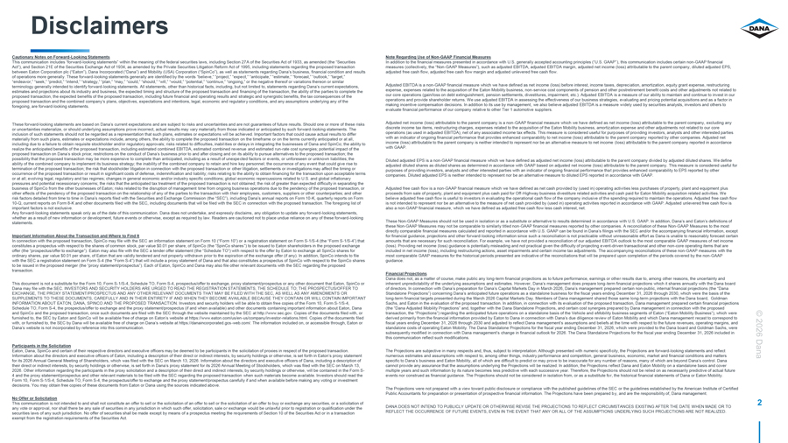
Disclaimers Cautionary Notes on Forward-Looking Statements Note Regarding Use of Non-GAAP Financial Measures This communication includes “forward-looking statements” within the meaning of the federal securities laws, including Section 27A of the Securities Act of 1933, as amended (the “Securities In addition to the financial measures presented in accordance with U.S. generally accepted accounting principles (“U.S. GAAP”), this communication includes certain non-GAAP financial Act”), and Section 21E of the Securities Exchange Act of 1934, as amended by the Private Securities Litigation Reform Act of 1995, including statements regarding the proposed transaction measures (collectively, the “Non-GAAP Measures”), such as adjusted EBITDA, adjusted EBITDA margin, adjusted net income (loss) attributable to the parent company, diluted adjusted EPS, between Eaton Corporation plc (“Eaton”), Dana Incorporated (“Dana”) and Mobility (USA) Corporation (“SpinCo”), as well as statements regarding Dana’s business, financial condition and results adjusted free cash flow, adjusted free cash flow margin and adjusted unlevered free cash flow. of operations more generally. These forward-looking statements generally are identified by the words “believe,” “project,” “expect,” “anticipate,” “estimate,” “forecast,” “outlook,” “target,” “endeavor,” “seek,” “predict,” “intend,” “strategy,” “plan,” “may,” “could,” “should,” “will,” “would,” “potential,” “continue,” “ongoing,” or the negative thereof or variations thereon or similar terminology generally intended to identify forward-looking statements. All statements, other than historical facts, including, but not limited to, statements regarding Dana’s current expectations, Adjusted EBITDA is a non-GAAP financial measure which we have defined as net income (loss) before interest, income taxes, depreciation, amortization, equity grant expense, restructuring estimates and projections about its industry and business, the expected timing and structure of the proposed transaction and financing of the transaction, the ability of the parties to complete the expense, expenses related to the acquisition of the Eaton Mobility business, non-service cost components of pension and other postretirement benefit costs and other adjustments not related to proposed transaction, the expected benefits of the proposed transaction, including future financial and operating results and strategic and synergistic benefits, the tax consequences of the our core operations (gain/loss on debt extinguishment, pension settlements, divestitures, impairment, etc.). Adjusted EBITDA is a measure of our ability to maintain and continue to invest in our proposed transaction and the combined company’s plans, objectives, expectations and intentions, legal, economic and regulatory conditions, and any assumptions underlying any of the operations and provide shareholder returns. We use adjusted EBITDA in assessing the effectiveness of our business strategies, evaluating and pricing potential acquisitions and as a factor in foregoing, are forward-looking statements. making incentive compensation decisions. In addition to its use by management, we also believe adjusted EBITDA is a measure widely used by securities analysts, investors and others to evaluate financial performance of our company relative to other Tier 1 automotive suppliers. These forward-looking statements are based on Dana’s current expectations and are subject to risks and uncertainties and are not guarantees of future results. Should one or more of these risks Adjusted net income (loss) attributable to the parent company is a non-GAAP financial measure which we have defined as net income (loss) attributable to the parent company, excluding any or uncertainties materialize, or should underlying assumptions prove incorrect, actual results may vary materially from those indicated or anticipated by such forward-looking statements. The discrete income tax items, restructuring charges, expenses related to the acquisition of the Eaton Mobility business, amortization expense and other adjustments not related to our core inclusion of such statements should not be regarded as a representation that such plans, estimates or expectations will be achieved. Important factors that could cause actual results to differ operations (as used in adjusted EBITDA), net of any associated income tax effects. This measure is considered useful for purposes of providing investors, analysts and other interested parties materially from such plans, estimates or expectations include, among others, the ability to complete the proposed transaction on the timeframe or on the terms currently anticipated or at all, with an indicator of ongoing financial performance that provides enhanced comparability to net income (loss) attributable to the parent company reported by other companies. Adjusted net including due to a failure to obtain requisite stockholder and/or regulatory approvals; risks related to difficulties, inabilities or delays in integrating the businesses of Dana and SpinCo; the ability to income (loss) attributable to the parent company is neither intended to represent nor be an alternative measure to net income (loss) attributable to the parent company reported in accordance realize the anticipated benefits of the proposed transaction, including estimated combined EBITDA, estimated combined revenue and estimated run-rate cost synergies; potential impact of the with GAAP. proposed transaction on Dana’s stock price; restrictions on the conduct of Dana’s business prior to and after closing and on its ability to pursue alternatives to the proposed transaction; the possibility that the proposed transaction may be more expensive to complete than anticipated, including as a result of unexpected factors or events, or unforeseen or unknown liabilities; the Diluted adjusted EPS is a non-GAAP financial measure which we have defined as adjusted net income (loss) attributable to the parent company divided by adjusted diluted shares. We define ability of the combined company to implement its business strategy; the inability of the combined company to retain and hire key personnel; the occurrence of any event that could give rise to adjusted diluted shares as diluted shares as determined in accordance with GAAP based on adjusted net income (loss) attributable to the parent company. This measure is considered useful for termination of the proposed transaction; the risk that stockholder litigation in connection with the proposed transaction or other litigation, settlements or investigations may affect the timing or purposes of providing investors, analysts and other interested parties with an indicator of ongoing financial performance that provides enhanced comparability to EPS reported by other occurrence of the proposed transaction or result in significant costs of defense, indemnification and liability; risks relating to the ability to obtain financing for the transaction upon acceptable terms companies. Diluted adjusted EPS is neither intended to represent nor be an alternative measure to diluted EPS reported in accordance with GAAP. or at all; evolving legal, regulatory and tax regimes; changes in general economic and/or industry specific conditions; global economic repercussions related to U.S. and global inflationary pressures and potential recessionary concerns; the risks that the anticipated tax treatment of the proposed transaction is not obtained; the risk of greater than expected difficulty in separating the business of SpinCo from the other businesses of Eaton; risks related to the disruption of management time from ongoing business operations due to the pendency of the proposed transaction, or Adjusted free cash flow is a non-GAAP financial measure which we have defined as net cash provided by (used in) operating activities less purchases of property, plant and equipment plus other effects of the pendency of the proposed transaction on the relationship of any of the parties to the transaction with their employees, customers, suppliers or other counterparties; and other proceeds from sale of property, plant and equipment plus cash paid for Off-Highway business divestiture related activities and cash paid for Eaton Mobility acquisition related activities. We risk factors detailed from time to time in Dana’s reports filed with the Securities and Exchange Commission (the “SEC”), including Dana’s annual reports on Form 10-K, quarterly reports on Form believe adjusted free cash flow is useful to investors in evaluating the operational cash flow of the company inclusive of the spending required to maintain the operations. Adjusted free cash flow 10-Q, current reports on Form 8-K and other documents filed with the SEC, including documents that will be filed with the SEC in connection with the proposed transaction. The foregoing list of is not intended to represent nor be an alternative to the measure of net cash provided by (used in) operating activities reported in accordance with GAAP. Adjusted unlevered free cash flow is important factors is not exclusive. also a non-GAAP financial measure, which we have defined as adjusted free cash flow less cash interest, net. Any forward-looking statements speak only as of the date of this communication. Dana does not undertake, and expressly disclaims, any obligation to update any forward-looking statements, whether as a result of new information or development, future events or otherwise, except as required by law. Readers are cautioned not to place undue reliance on any of these forward-looking statements. These Non-GAAP Measures should not be used in isolation or as a substitute or alternative to results determined in accordance with U.S. GAAP. In addition, Dana’s and Eaton’s definitions of these Non-GAAP Measures may not be comparable to similarly titled non-GAAP financial measures reported by other companies. A reconciliation of these Non-GAAP Measures to the most directly comparable financial measures calculated and reported in accordance with U.S. GAAP can be found in Dana’s filings with the SEC and/or the accompanying financial information, except Important Information About the Transaction and Where to Find It for financial guidance, projections and other forward-looking information since such a reconciliation is not practicable without unreasonable effort as Dana is unable to reasonably forecast certain In connection with the proposed transaction, SpinCo may file with the SEC an information statement on Form 10 (“Form 10”) or a registration statement on Form S-1/S-4 (the “Form S-1/S-4”) that amounts that are necessary for such reconciliation. For example, we have not provided a reconciliation of our adjusted EBITDA outlook to the most comparable GAAP measures of net income constitutes a prospectus with respect to the shares of common stock, par value $0.01 per share, of SpinCo (the “SpinCo shares”) to be issued to Eaton shareholders in the proposed exchange (loss). Providing net income (loss) guidance is potentially misleading and not practical given the difficulty of projecting event-driven transactional and other non-core operating items that are offer (the “prospectus/offer to exchange”). Eaton may also file with the SEC a tender offer statement (the “Schedule TO”) with respect to the offer by Eaton to exchange all SpinCo shares for included in net income (loss), including restructuring actions, asset impairments and certain income tax adjustments. The accompanying reconciliations of these non-GAAP measures with the ordinary shares, par value $0.01 per share, of Eaton that are validly tendered and not properly withdrawn prior to the expiration of the exchange offer (if any). In addition, SpinCo intends to file most comparable GAAP measures for the historical periods presented are indicative of the reconciliations that will be prepared upon completion of the periods covered by the non-GAAP with the SEC a registration statement on Form S-4 (the “Form S-4”) that will include a proxy statement of Dana and that also constitutes a prospectus of SpinCo with respect to the SpinCo shares guidance. to be issued in the proposed merger (the “proxy statement/prospectus”). Each of Eaton, SpinCo and Dana may also file other relevant documents with the SEC regarding the proposed transaction. Financial Projections Dana does not, as a matter of course, make public any long-term financial projections as to future performance, earnings or other results due to, among other reasons, the uncertainty and This document is not a substitute for the Form 10, Form S-1/S-4, Schedule TO, Form S-4, prospectus/offer to exchange, proxy statement/prospectus or any other document that Eaton, SpinCo or inherent unpredictability of the underlying assumptions and estimates. However, Dana’s management does prepare long-term financial projections which it shares annually with the Dana board Dana may file with the SEC. INVESTORS AND SECURITY HOLDERS ARE URGED TO READ THE REGISTRATION STATEMENTS, THE SCHEDULE TO; THE PROSPECTUS/OFFER TO of directors. In connection with Dana’s preparation for Dana’s Capital Markets Day in March 2026, Dana’s management prepared certain non-public, internal financial projections (the “Dana EXCHANGE, THE PROXY STATEMENT/PROSPECTUS AND ANY OTHER RELEVANT DOCUMENTS THAT MAY BE FILED WITH THE SEC, AS WELL AS ANY AMENDMENTS OR Standalone Projections”) concerning Dana’s anticipated future operations as a standalone business for the fiscal years ending December 31, 2026 through 2030, which were the basis of the SUPPLEMENTS TO THESE DOCUMENTS, CAREFULLY AND IN THEIR ENTIRETY IF AND WHEN THEY BECOME AVAILABLE BECAUSE THEY CONTAIN OR WILL CONTAIN IMPORTANT long-term financial targets presented during the March 2026 Capital Markets Day. Members of Dana management shared those same long-term projections with the Dana board, Goldman INFORMATION ABOUT EATON, DANA, SPINCO AND THE PROPOSED TRANSACTION. Investors and security holders will be able to obtain free copies of the Form 10, Form S-1/S-4, Sachs, and Eaton in the evaluation of the proposed transaction. In addition, in connection with its evaluation of the proposed transaction, Dana management prepared certain financial projections Schedule TO, Form S-4, the prospectus/offer to exchange and the proxy statement/prospectus (if and when available) and other documents containing important information about Eaton, Dana (the “Dana Adjusted Mobility Projections” and, together with the Dana Standalone Projections, and certain cost synergies prepared by Dana management in connection with the proposed and SpinCo and the proposed transaction, once such documents are filed with the SEC through the website maintained by the SEC at http://www.sec.gov. Copies of the documents filed with, or transaction, the “Projections”) regarding the anticipated future operations on a standalone basis of the Vehicle and eMobility business segments of Eaton (“Eaton Mobility Business”), which were © furnished to, the SEC by Eaton and SpinCo will be available free of charge on Eaton’s website at https://www.eaton.com/us/en-us/company/investor-relations.html. Copies of the documents filed derived primarily from the financial information provided by Eaton to Dana in connection with Dana’s due diligence review of Eaton Mobility and which Dana management recast to correspond to with, or furnished to, the SEC by Dana will be available free of charge on Dana’s website at https://danaincorporated.gcs-web.com/. The information included on, or accessible through, Eaton or fiscal years ending December 31, 2026 through 2030 and adjusted to reflect Dana management’s assumptions and beliefs at the time with respect to the future revenues, operating margins, and Dana’s website is not incorporated by reference into this communication. standalone costs of operating Eaton Mobility. The Dana Standalone Projections for the fiscal year ending December 31, 2026, which were provided to the Dana board and Goldman Sachs, were subsequently modified in connection with Dana management’s change in financial outlook for 2026. The Dana Standalone Projections for the fiscal year ending December 31, 2026 included in 2026 this communication reflect such modifications. Participants in the Solicitation Eaton, Dana, SpinCo and certain of their respective directors and executive officers may be deemed to be participants in the solicitation of proxies in respect of the proposed transaction. The Projections are subjective in many respects and, thus, subject to interpretation. Although presented with numeric specificity, the Projections are forward-looking statements and reflect Information about the directors and executive officers of Eaton, including a description of their direct or indirect interests, by security holdings or otherwise, is set forth in Eaton’s proxy statement numerous estimates and assumptions with respect to, among other things, industry performance and competition, general business, economic, market and financial conditions and matters Dana for its 2026 Annual General Meeting of Shareholders, which was filed with the SEC on March 13, 2026. Information about the directors and executive officers of Dana, including a description of specific to Dana’s business and Eaton Mobility, all of which are difficult to predict or may prove to be inaccurate for any number of reasons, many of which are beyond Dana’s control. Dana their direct or indirect interests, by security holdings or otherwise, is set forth in Dana’s proxy statement for its 2026 Annual Meeting of Stockholders, which was filed with the SEC on March 13, cannot provide any assurance that the assumptions underlying the Projections will be realized. In addition, the Projections reflect Dana and Eaton Mobility on a standalone basis and cover 2026. Other information regarding the participants in the proxy solicitation and a description of their direct and indirect interests, by security holdings or otherwise, will be contained in the Form S- multiple years and such information by its nature becomes less predictive with each successive year. Therefore, the Projections should not be relied on as necessarily predictive of actual future 4 and the proxy statement/prospectus and other relevant materials to be filed with the SEC regarding the proposed transaction when such materials become available. Investors should read the events nor construed as financial guidance. The Projections should not be considered in isolation from, or as a substitute for, the historical financial statements of Dana or Eaton Mobility. Form 10, Form S-1/S-4, Schedule TO, Form S-4, the prospectus/offer to exchange and the proxy statement/prospectus carefully if and when available before making any voting or investment decisions. You may obtain free copies of these documents from Eaton or Dana using the sources indicated above. The Projections were not prepared with a view toward public disclosure or compliance with the published guidelines of the SEC or the guidelines established by the American Institute of Certified Public Accountants for preparation or presentation of prospective financial information. The Projections have been prepared by, and are the responsibility of, Dana management. No Offer or Solicitation This communication is not intended to and shall not constitute an offer to sell or the solicitation of an offer to sell or the solicitation of an offer to buy or exchange any securities, or a solicitation of 2 any vote or approval, nor shall there be any sale of securities in any jurisdiction in which such offer, solicitation, sale or exchange would be unlawful prior to registration or qualification under the DANA DOES NOT INTEND TO PUBLICLY UPDATE OR OTHERWISE REVISE THE PROJECTIONS TO REFLECT CIRCUMSTANCES EXISTING AFTER THE DATE WHEN MADE OR TO securities laws of any such jurisdiction. No offer of securities shall be made except by means of a prospectus meeting the requirements of Section 10 of the Securities Act or in a transaction REFLECT THE OCCURRENCE OF FUTURE EVENTS, EVEN IN THE EVENT THAT ANY OR ALL OF THE ASSUMPTIONS UNDERLYING SUCH PROJECTIONS ARE NOT REALIZED. exempt from the registration requirements of the Securities Act.

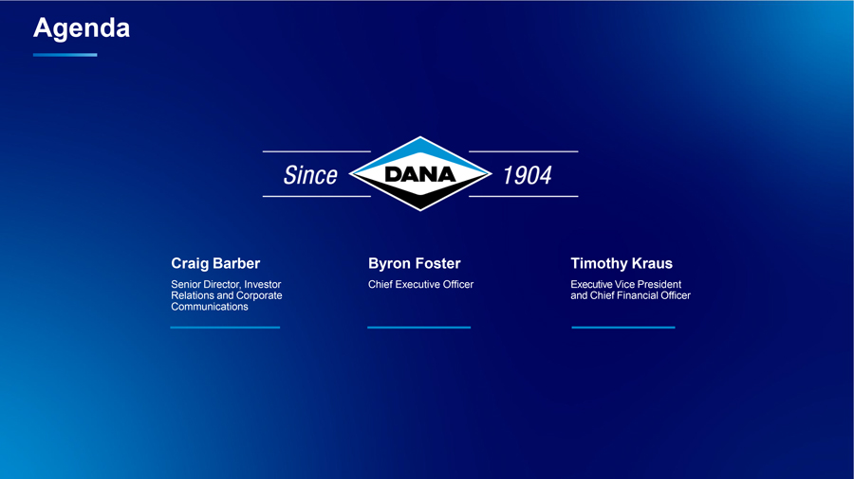
Agenda Craig Barber Byron Foster Timothy Kraus Senior Director, Investor Chief Executive Officer Executive Vice President Relations and Corporate and Chief Financial Officer Communications

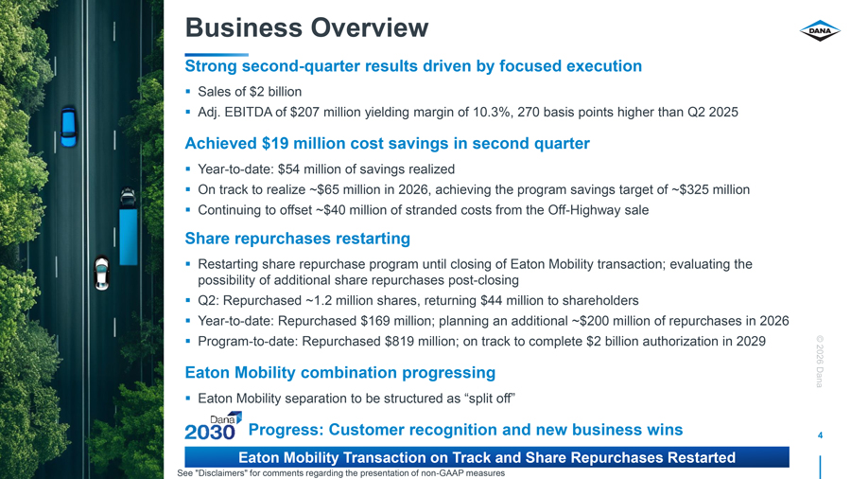
Business Overview Strong second-quarter results driven by focused execution Sales of $2 billion Adj. EBITDA of $207 million yielding margin of 10.3%, 270 basis points higher than Q2 2025 Achieved $19 million cost savings in second quarter Year-to-date: $54 million of savings realized On track to realize ~$65 million in 2026, achieving the program savings target of ~$325 million Continuing to offset ~$40 million of stranded costs from the Off-Highway sale Share repurchases restarting Restarting share repurchase program until closing of Eaton Mobility transaction; evaluating the possibility of additional share repurchases post-closing Q2: Repurchased ~1.2 million shares, returning $44 million to shareholders Year-to-date: Repurchased $169 million; planning an additional ~$200 million of repurchases in 2026 Program-to-date: Repurchased $819 million; on track to complete $2 billion authorization in 2029 © 2026 Eaton Mobility combination progressing Dana Eaton Mobility separation to be structured as “split off” Progress: Customer recognition and new business wins 4 Eaton Mobility Transaction on Track and Share Repurchases Restarted See “Disclaimers” for comments regarding the presentation of non-GAAP measures


© 2026 Dana 5 Awards Customer

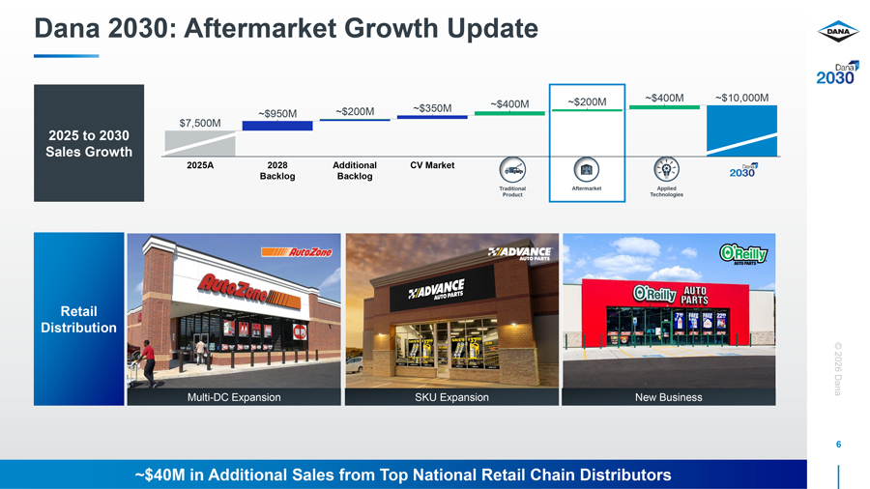
Dana 2030: Aftermarket Growth Update ~$200M ~$400M ~$10,000M ~$350M ~$400M ~$950M ~$200M $7,500M 2025 to 2030 Sales Growth 2025A 2028 Additional CV Market Backlog Backlog Traditional Aftermarket Applied Product Technologies Retail Distribution © 2026 Multi-DC Expansion SKU Expansion New Business Dana 6 ~$40M in Additional Sales from Top National Retail Chain Distributors

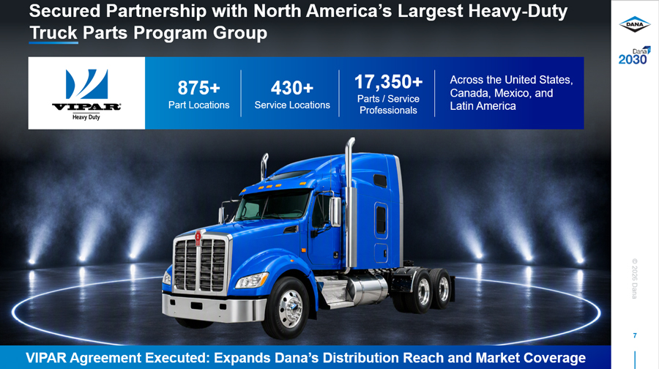
Secured Partnership with North America’s Largest Heavy-Duty Truck Parts Program Group 875+ 430+ 17,350+ Across the United States, Canada, Mexico, and Parts / Service Part Locations Service Locations Latin America Professionals © 2026 Dana 7 VIPAR Agreement Executed: Expands Dana’s Distribution Reach and Market Coverage

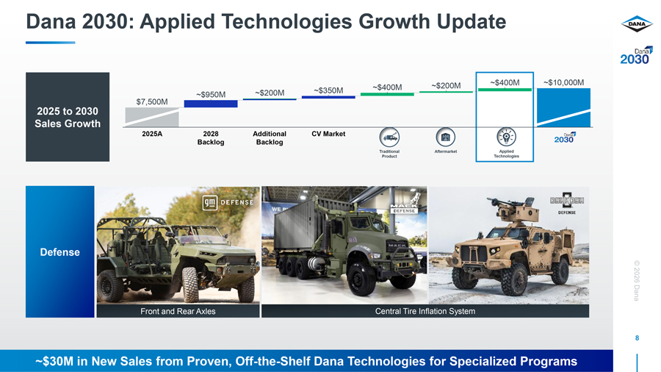
Dana 2030: Applied Technologies Growth Update ~$200M ~$400M ~$10,000M ~$350M ~$400M ~$950M ~$200M $7,500M 2025 to 2030 Sales Growth 2025A 2028 Additional CV Market Backlog Backlog Traditional Aftermarket Applied Product Technologies Defense © 2026 Dana Front and Rear Axles Central Tire Inflation System 8 ~$30M in New Sales from Proven, Off-the-Shelf Dana Technologies for Specialized Programs

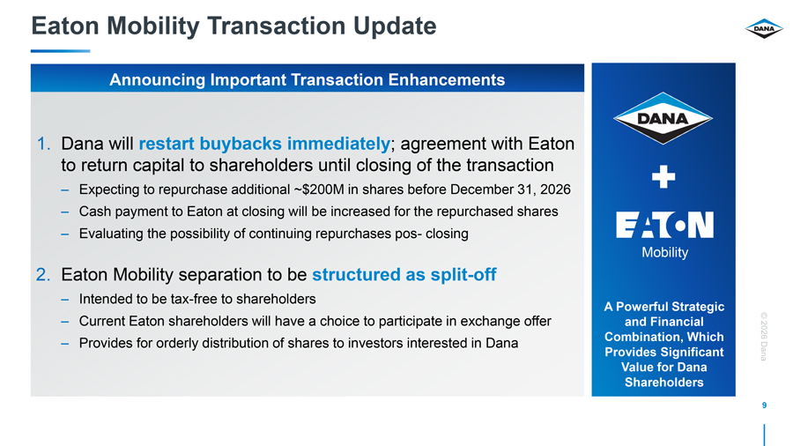
Eaton Mobility Transaction Update Announcing Important Transaction Enhancements 1. Dana will restart buybacks immediately; agreement with Eaton to return capital to shareholders until closing of the transaction – Expecting to repurchase additional ~$200M in shares before December 31, 2026 – Cash payment to Eaton at closing will be increased for the repurchased shares – Evaluating the possibility of continuing repurchases pos- closing Mobility 2. Eaton Mobility separation to be structured as split-off – Intended to be tax-free to shareholders A Powerful Strategic – Current Eaton shareholders will have a choice to participate in exchange offer and Financial © Combination, Which 2026 – Provides for orderly distribution of shares to investors interested in Dana Provides Significant Dana Value for Dana Shareholders 9

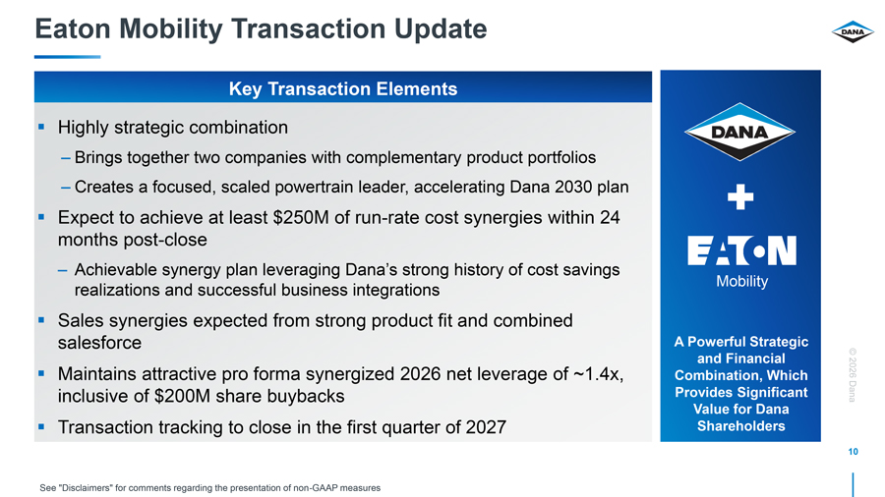
Eaton Mobility Transaction Update Key Transaction Elements Highly strategic combination – Brings together two companies with complementary product portfolios – Creates a focused, scaled powertrain leader, accelerating Dana 2030 plan Expect to achieve at least $250M of run-rate cost synergies within 24 months post-close – Achievable synergy plan leveraging Dana’s strong history of cost savings Mobility realizations and successful business integrations Sales synergies expected from strong product fit and combined salesforce A Powerful Strategic and Financial © Maintains attractive pro forma synergized 2026 net leverage of ~1.4x, Combination, Which 2026 inclusive of $200M share buybacks Provides Significant Dana Value for Dana Transaction tracking to close in the first quarter of 2027 Shareholders 10 See “Disclaimers” for comments regarding the presentation of non-GAAP measures

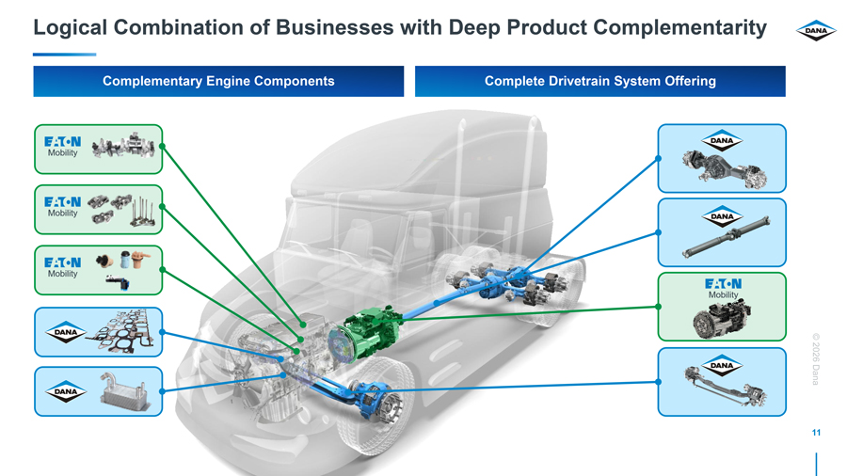
Logical Combination of Businesses with Deep Product Complementarity Complementary Engine Components Complete Drivetrain System Offering © 2026 Dana 11

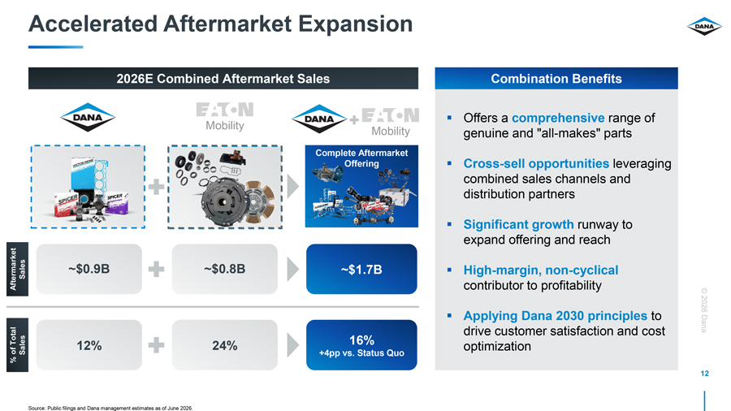
Accelerated Aftermarket Expansion 2026E Combined Aftermarket Sales Combination Benefits Offers a comprehensive range of Mobility Mobility genuine and “all-makes” parts Complete Aftermarket Offering Cross-sell opportunities leveraging combined sales channels and distribution partners Significant growth runway to expand offering and reach Sales ~$0.9B ~$0.8B ~$1.7B High-margin, non-cyclical Aftermarket contributor to profitability © 2026 Applying Dana 2030 principles to drive customer satisfaction and cost Dana Total 16% of Sales 12% 24% optimization +4pp vs. Status Quo % 12

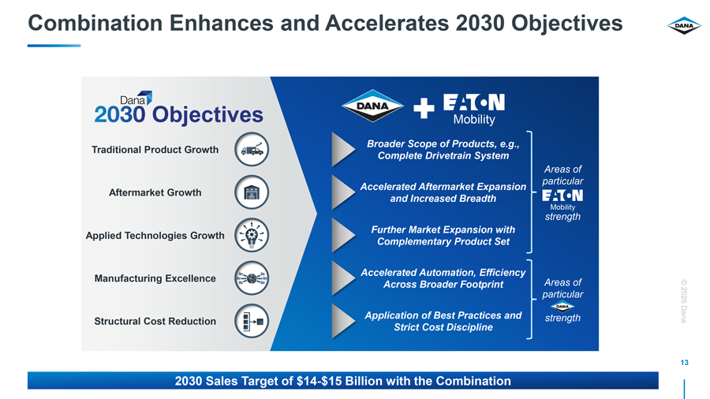
Combination Enhances and Accelerates 2030 Objectives Objectives Mobility Broader Scope of Products, e.g., Traditional Product Growth Complete Drivetrain System Areas of particular Accelerated Aftermarket Expansion Aftermarket Growth and Increased Breadth Mobility strength Further Market Expansion with Applied Technologies Growth Complementary Product Set Accelerated Automation, Efficiency Manufacturing Excellence Across Broader Footprint Areas of © particular 2026 Application of Best Practices and strength Dana Structural Cost Reduction Strict Cost Discipline 13 2030 Sales Target of $14-$15 Billion with the Combination

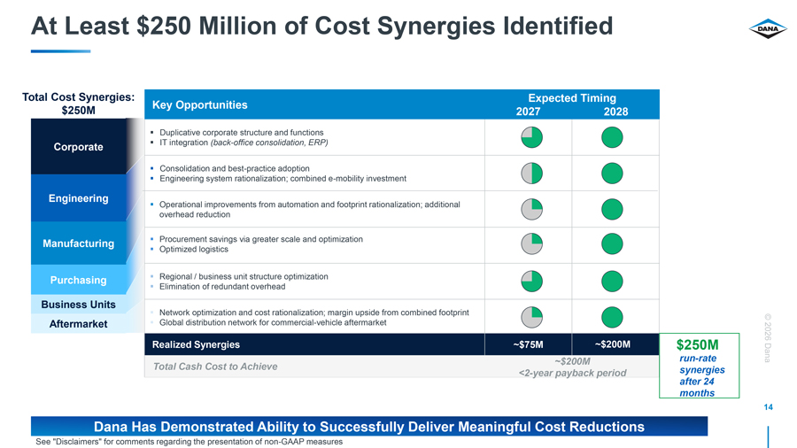
At Least $250 Million of Cost Synergies Identified Total Cost Synergies: Expected Timing $250M Key Opportunities 2027 2028 Duplicative corporate structure and functions Corporate IT integration (back-office consolidation, ERP) Consolidation and best-practice adoption Engineering system rationalization; combined e-mobility investment Engineering Operational improvements from automation and footprint rationalization; additional overhead reduction Manufacturing Procurement savings via greater scale and optimization Optimized logistics Purchasing Regional / business unit structure optimization Elimination of redundant overhead Business Units Network optimization and cost rationalization; margin upside from combined footprint © Aftermarket Global distribution network for commercial-vehicle aftermarket 2026 Realized Synergies ~$75M ~$200M $250M ~$200M run-rate Dana Total Cash Cost to Achieve synergies <2-year payback period after 24 months 14 Dana Has Demonstrated Ability to Successfully Deliver Meaningful Cost Reductions See “Disclaimers” for comments regarding the presentation of non-GAAP measures

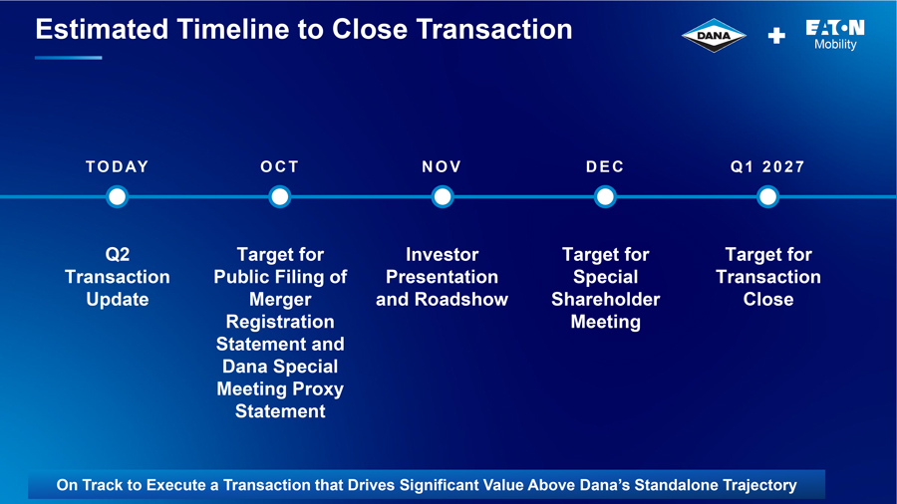
Estimated Timeline to Close Transaction Mobility TO D AY OC T N OV D EC Q1 2 0 2 7 Q2 Target for Investor Target for Target for Transaction Public Filing of Presentation Special Transaction Update Merger and Roadshow Shareholder Close Registration Meeting Statement and Dana Special © 2026 Meeting Proxy Statement Dana 15 On Track to Execute a Transaction that Drives Significant Value Above Dana’s Standalone Trajectory


Financial Review

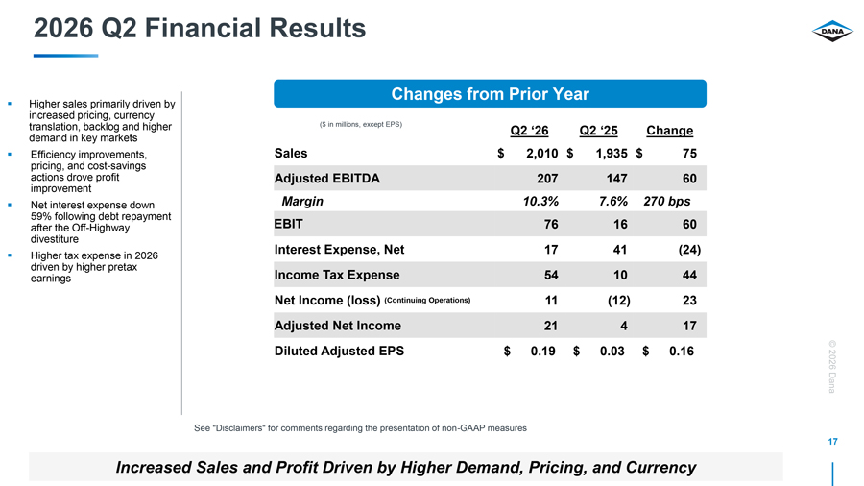
2026 Q2 Financial Results Changes from Prior Year Higher sales primarily driven by increased pricing, currency translation, backlog and higher ($ in millions, except EPS) Q2 ‘26 Q2 ‘25 Change demand in key markets Efficiency improvements, Sales $ 2,010 $ 1,935 $ 75 pricing, and cost-savings actions drove profit Adjusted EBITDA 207 147 60 improvement Net interest expense down Margin 10.3% 7.6% 270 bps 59% following debt repayment EBIT 76 16 60 after the Off-Highway divestiture Interest Expense, Net 17 41 (24) Higher tax expense in 2026 driven by higher pretax Income Tax Expense earnings 54 10 44 Net Income (loss) (Continuing Operations) 11 (12) 23 Adjusted Net Income 21 4 17 Diluted Adjusted EPS $ 0.19 $ 0.03 $ 0.16 © 2026 Dana See “Disclaimers” for comments regarding the presentation of non-GAAP measures 17 Increased Sales and Profit Driven by Higher Demand, Pricing, and Currency

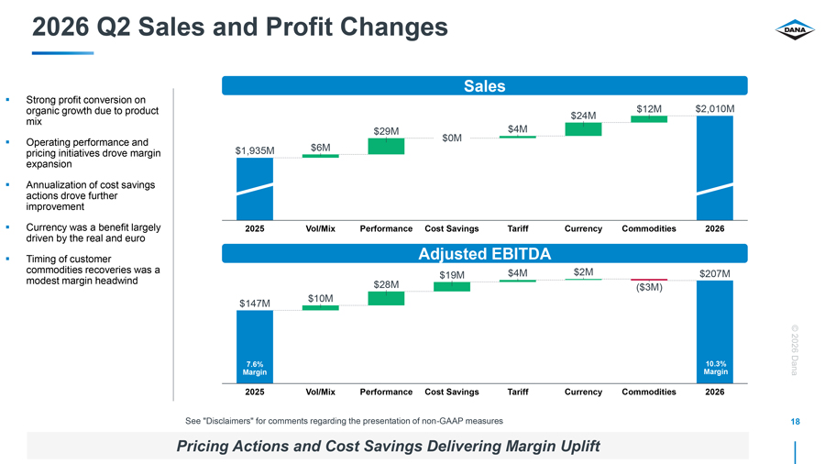
2026 Q2 Sales and Profit Changes Sales Strong profit conversion on $12M $2,010M organic growth due to product $24M mix $29M $0M $4M Operating performance and $1,935M $6M pricing initiatives drove margin expansion Annualization of cost savings actions drove further improvement Currency was a benefit largely 2025 Vol/Mix Performance Cost Savings Tariff Currency Commodities 2026 driven by the real and euro Timing of customer Adjusted EBITDA commodities recoveries was a $4M $2M $207M $19M modest margin headwind $28M ($3M) $10M $147M © 2026 7.6% Margin 4.7% Margin 10.3% Margin Dana 2025 Vol/Mix Performance Cost Savings Tariff Currency Commodities 2026 See “Disclaimers” for comments regarding the presentation of non-GAAP measures 18 Pricing Actions and Cost Savings Delivering Margin Uplift

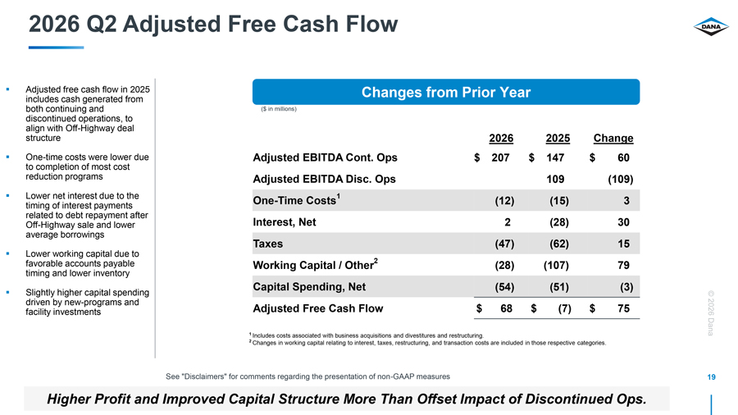
2026 Q2 Adjusted Free Cash Flow Adjusted free cash flow in 2025 Changes from Prior Year includes cash generated from both continuing and ($ in millions) discontinued operations, to align with Off-Highway deal structure 2026 2025 Change One-time costs were lower due Adjusted EBITDA Cont. Ops $ 207 $ 147 $ 60 to completion of most cost reduction programs Adjusted EBITDA Disc. Ops 109 (109) Lower net interest due to the One-Time Costs1 (12) (15) 3 timing of interest payments related to debt repayment after Off-Highway sale and lower Interest, Net 2 (28) 30 average borrowings Taxes (47) (62) 15 Lower working capital due to favorable accounts payable Working Capital / Other2 (28) (107) 79 timing and lower inventory Capital Spending, Net (54) (51) (3) Slightly higher capital spending © driven by new-programs and facility investments Adjusted Free Cash Flow $ 68 $ (7) $ 75 2026 1 Includes costs associated with business acquisitions and divestitures and restructuring. Dana 2 Changes in working capital relating to interest, taxes, restructuring, and transaction costs are included in those respective categories. See “Disclaimers” for comments regarding the presentation of non-GAAP measures 19 Higher Profit and Improved Capital Structure More Than Offset Impact of Discontinued Ops.

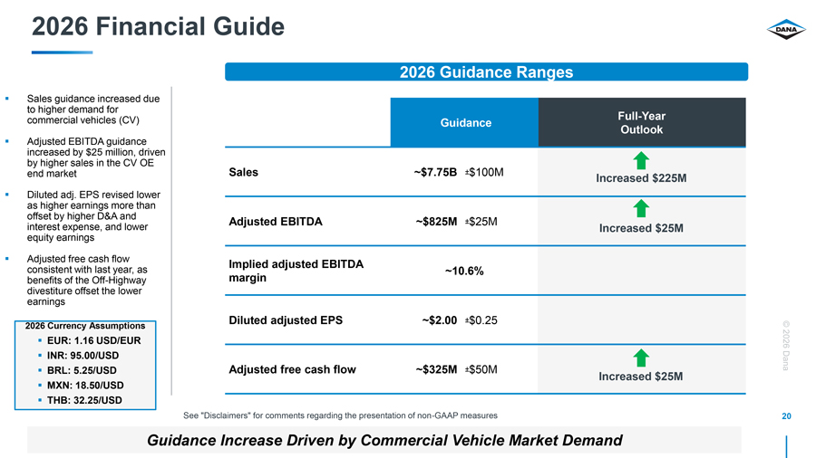
2026 Financial Guide 2026 Guidance Ranges Sales guidance increased due to higher demand for Full-Year commercial vehicles (CV) Guidance Outlook Adjusted EBITDA guidance increased by $25 million, driven by higher sales in the CV OE end market Sales ~$7.75B ±$100M Increased $225M Diluted adj. EPS revised lower as higher earnings more than offset by higher D&A and Adjusted EBITDA ~$825M ±$25M interest expense, and lower Increased $25M equity earnings Adjusted free cash flow Implied adjusted EBITDA consistent with last year, as ~10.6% benefits of the Off-Highway margin divestiture offset the lower earnings Diluted adjusted EPS ~$2.00 ±$0.25 2026 Currency Assumptions© EUR: 1.16 USD/EUR 2026 INR: 95.00/USD Dana BRL: 5.25/USD Adjusted free cash flow ~$325M ±$50M Increased $25M MXN: 18.50/USD THB: 32.25/USD See “Disclaimers” for comments regarding the presentation of non-GAAP measures 20 Guidance Increase Driven by Commercial Vehicle Market Demand

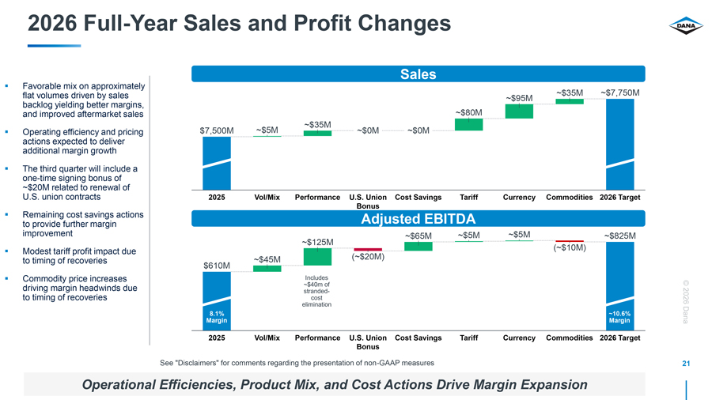
2026 Full-Year Sales and Profit Changes Sales Favorable mix on approximately flat volumes driven by sales ~$35M ~$7,750M ~$95M backlog yielding better margins, ~$80M and improved aftermarket sales ~$35M Operating efficiency and pricing $7,500M ~$5M ~$0M ~$0M actions expected to deliver additional margin growth The third quarter will include a one-time signing bonus of ~$20M related to renewal of U.S. union contracts 2025 Vol/Mix Performance U.S. Union Cost Savings Tariff Currency Commodities 2026 Target Bonus Remaining cost savings actions Adjusted EBITDA to provide further margin improvement ~$65M ~$5M ~$5M ~$825M ~$125M Modest tariff profit impact due (~$10M) to timing of recoveries ~$45M (~$20M) $610M Commodity price increases Includes © ~$40m of driving margin headwinds due stranded- to timing of recoveries cost 2026 elimination Margin 8.1% ~10 Margin .6% Dana 2025 Vol/Mix Performance U.S. Union Cost Savings Tariff Currency Commodities 2026 Target Bonus See “Disclaimers” for comments regarding the presentation of non-GAAP measures 21 Operational Efficiencies, Product Mix, and Cost Actions Drive Margin Expansion

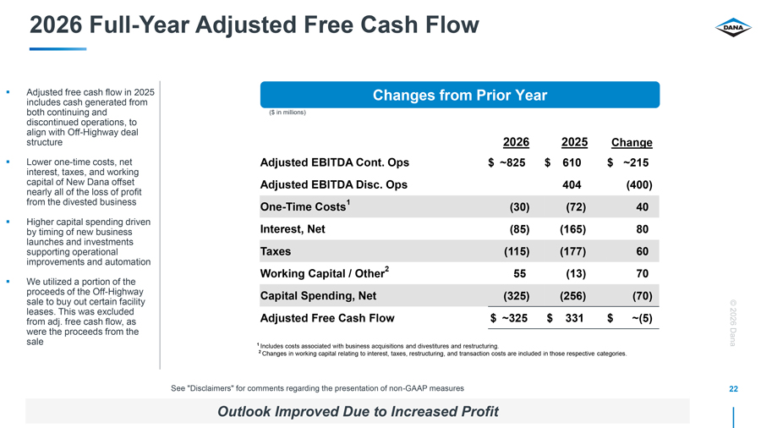
2026 Full-Year Adjusted Free Cash Flow Adjusted free cash flow in 2025 Changes from Prior Year includes cash generated from both continuing and ($ in millions) discontinued operations, to align with Off-Highway deal structure 2026 2025 Change Lower one-time costs, net Adjusted EBITDA Cont. Ops $ ~825 $ 610 $ ~215 interest, taxes, and working capital of New Dana offset Adjusted EBITDA Disc. Ops 404 (400) nearly all of the loss of profit from the divested business One-Time Costs1 (30) (72) 40 Higher capital spending driven by timing of new business Interest, Net (85) (165) 80 launches and investments supporting operational Taxes (115) (177) 60 improvements and automation Working Capital / Other2 55 (13) 70 We utilized a portion of the proceeds of the Off-Highway Capital Spending, Net (325) (256) (70) sale to buy out certain facility © leases. This was excluded from adj. free cash flow, as Adjusted Free Cash Flow $ ~325 $ 331 $ ~(5) 2026 were the proceeds from the sale 1 Dana Includes costs associated with business acquisitions and divestitures and restructuring. 2 Changes in working capital relating to interest, taxes, restructuring, and transaction costs are included in those respective categories. See “Disclaimers” for comments regarding the presentation of non-GAAP measures 22 Outlook Improved Due to Increased Profit

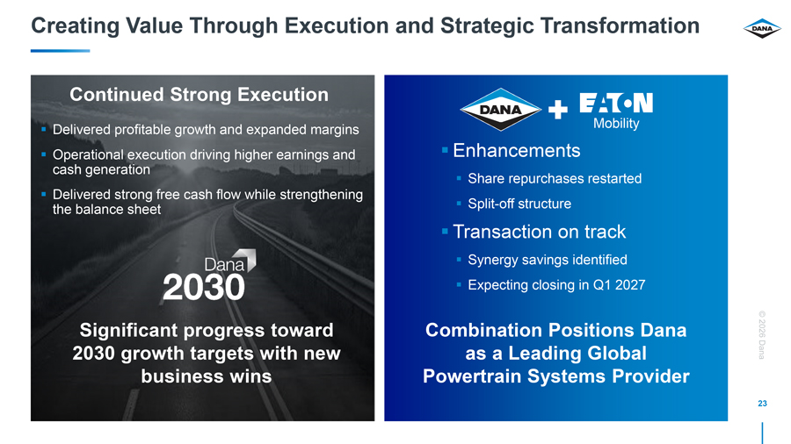
Creating Value Through Execution and Strategic Transformation Transaction on Track Continued Strong Execution Delivered growth and Mobility profitable expanded margins Operational execution driving higher earnings and Combination Enhancement Positions s Dana cash generation as a Leading Share repurchases Global restarted Delivered strong free cash flow while strengthening the balance sheet Powertrain Split Systems -off structure Provider Transaction on track Synergy savings identified Expecting closing in Q1 2027 © Significant progress toward Combination Positions Dana 2026 2030 growth targets with new as a Leading Global Dana business wins Powertrain Systems Provider 23

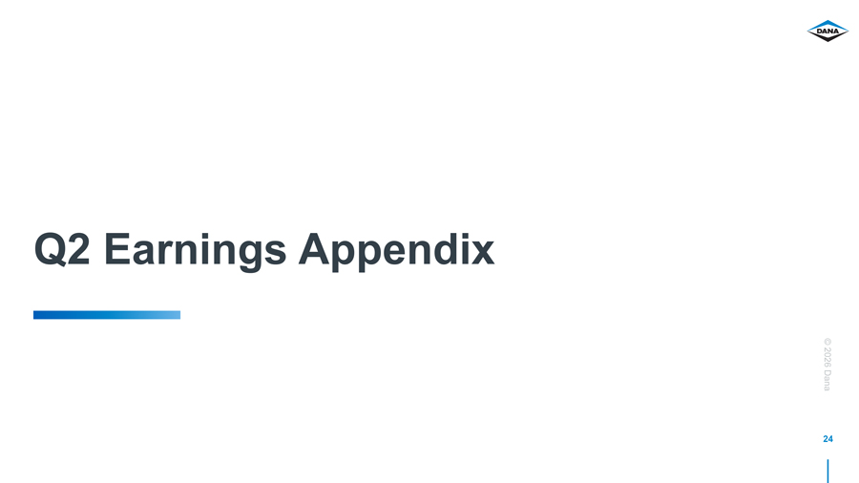
Q2 Earnings Appendix © 2026 Dana 24

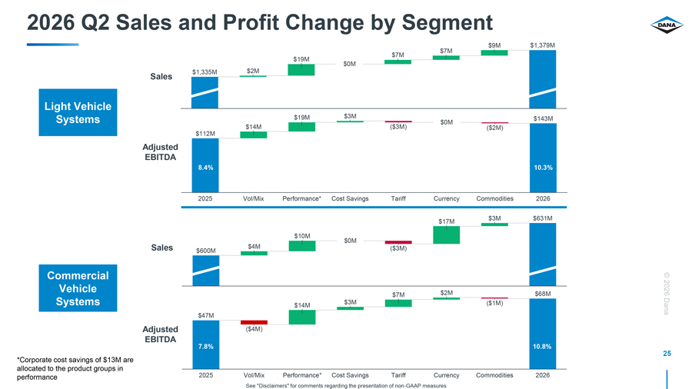
2026 Q2 Sales and Profit Change by Segment $9M $1,379M $7M $7M $19M $0M $1,335M $2M Sales Light Vehicle Systems $19M $3M $0M $143M $14M ($3M) ($2M) $112M Adjusted EBITDA 8.4% 10.3% 2025 Vol/Mix Performance* Cost Savings Tariff Currency Commodities 2026 $3M $631M $17M $10M $4M $0M Sales $600M ($3M) Commercial © Vehicle $2M 2026 $7M $68M Systems 3.2% $3M ($1M) $14M Dana $47M Adjusted ($4M) EBITDA 7.8% 10.8% *Corporate cost savings of $13M are 25 allocated to the product groups in performance 2025 Vol/Mix Performance* Cost Savings Tariff Currency Commodities 2026 See “Disclaimers” for comments regarding the presentation of non-GAAP measures

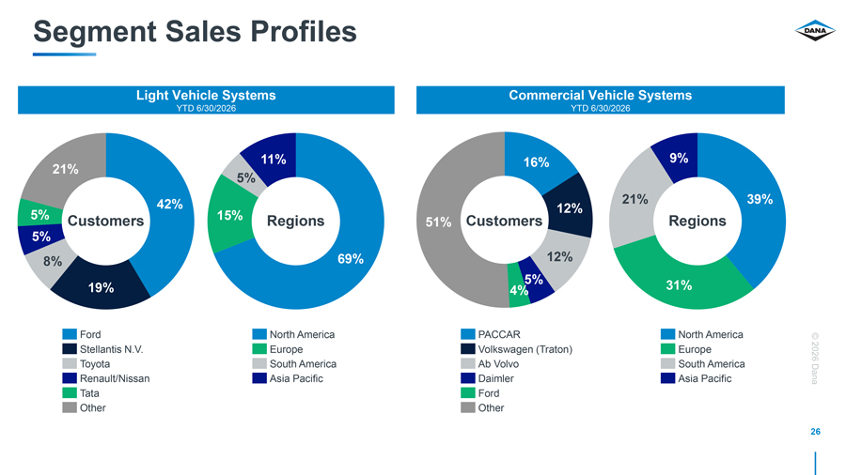
Segment Sales Profiles Light Vehicle Systems Commercial Vehicle Systems YTD 6/30/2026 YTD 6/30/2026 11% 16% 9% 21% 5% 42% 21% 39% 5% 12% Customers 15% Regions 51% Customers Regions 5% 8% 69% 12% 5% 31% 19% 4% Ford North America PACCAR North America © Stellantis N.V. Europe Volkswagen (Traton) Europe 2026 Toyota South America Ab Volvo South America Renault/Nissan Asia Pacific Daimler Asia Pacific Dana Tata Ford Other Other 26

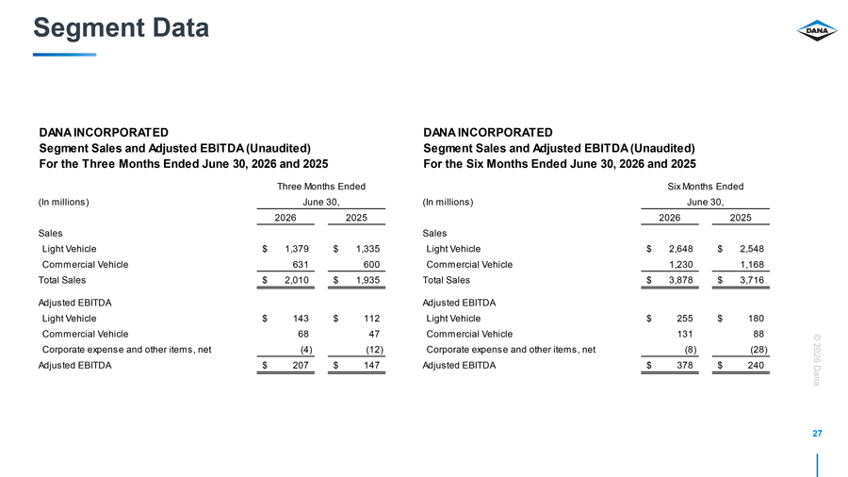
Segment Data DANA INCORPORATED DANA INCORPORATED Segment Sales and Adjusted EBITDA (Unaudited) Segment Sales and Adjusted EBITDA (Unaudited) For the Three Months Ended June 30, 2026 and 2025 For the Six Months Ended June 30, 2026 and 2025 Three Months Ended Six Months Ended (In millions) June 30, (In millions) June 30, 2026 2025 2026 2025 Sales Sales Light Vehicle $ 1,379 $ 1,335 Light Vehicle $ 2,648 $ 2,548 Commercial Vehicle 631 600 Commercial Vehicle 1,230 1,168 Total Sales $ 2,010 $ 1,935 Total Sales $ 3,878 $ 3,716 Adjusted EBITDA Adjusted EBITDA Light Vehicle $ 143 $ 112 Light Vehicle $ 255 $ 180 Commercial Vehicle 68 47 Commercial Vehicle 131 88 © Corporate expense and other items, net (4) (12) Corporate expense and other items, net (8) (28) 2026 Adjusted EBITDA $ 207 $ 147 Adjusted EBITDA $ 378 $ 240Dana 27

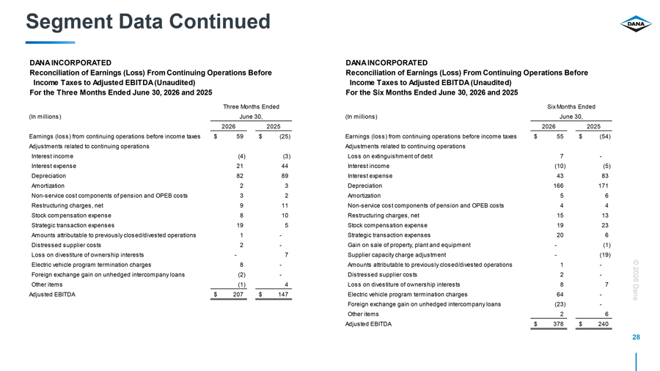
Segment Data Continued DANA INCORPORATED DANA INCORPORATED Reconciliation of Earnings (Loss) From Continuing Operations Before Reconciliation of Earnings (Loss) From Continuing Operations Before Income Taxes to Adjusted EBITDA (Unaudited) Income Taxes to Adjusted EBITDA (Unaudited) For the Three Months Ended June 30, 2026 and 2025 For the Six Months Ended June 30, 2026 and 2025 Three Months Ended Six Months Ended (In millions) June 30, (In millions) June 30, 2026 2025 2026 2025 Earnings (loss) from continuing operations before income taxes $ 59 $ (25) Earnings (loss) from continuing operations before income taxes $ 55 $ (54) Adjustments related to continuing operations Adjustments related to continuing operations Interest income (4) (3) Loss on extinguishment of debt 7 -Interest expense 21 44 Interest income (10) (5) Depreciation 82 89 Interest expense 43 83 Amortization 2 3 Depreciation 166 171 Non-service cost components of pension and OPEB costs 3 2 Amortization 5 6 Restructuring charges, net 9 11 Non-service cost components of pension and OPEB costs 4 4 Stock compensation expense 8 10 Restructuring charges, net 15 13 Strategic transaction expenses 19 5 Stock compensation expense 19 23 Amounts attributable to previously closed/divested operations 1 —Strategic transaction expenses 20 6 Distressed supplier costs 2 —Gain on sale of property, plant and equipment — (1) Loss on divestiture of ownership interests — 7 Supplier capacity charge adjustment — (19) Electric vehicle program termination charges 8 —Amounts attributable to previously closed/divested operations 1 —© Foreign exchange gain on unhedged intercompany loans (2) —Distressed supplier costs 2 —2026 Other items (1) 4 Loss on divestiture of ownership interests 8 7 Adjusted EBITDA $ 207 $ 147 Electric vehicle program termination charges 64 —Dana Foreign exchange gain on unhedged intercompany loans (23) -Other items 2 6 Adjusted EBITDA $ 378 $ 240 28

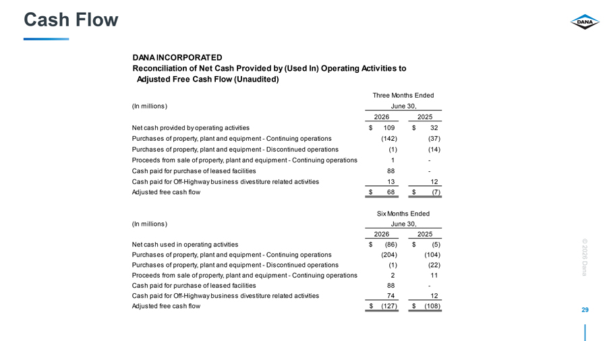
Cash Flow DANA INCORPORATED Reconciliation of Net Cash Provided by (Used In) Operating Activities to Adjusted Free Cash Flow (Unaudited) Three Months Ended (In millions) June 30, 2026 2025 Net cash provided by operating activities $ 109 $ 32 Purchases of property, plant and equipment—Continuing operations (142) (37) Purchases of property, plant and equipment—Discontinued operations (1) (14) Proceeds from sale of property, plant and equipment—Continuing operations 1 -Cash paid for purchase of leased facilities 88 -Cash paid for Off-Highway business divestiture related activities 13 12 Adjusted free cash flow $ 68 $ (7) Six Months Ended (In millions) June 30, 2026 2025 Net cash used in operating activities $ (86) $ (5) © Purchases of property, plant and equipment—Continuing operations (204) (104) 2026 Purchases of property, plant and equipment—Discontinued operations (1) (22) Dana Proceeds from sale of property, plant and equipment—Continuing operations 2 11 Cash paid for purchase of leased facilities 88 -Cash paid for Off-Highway business divestiture related activities 74 12 Adjusted free cash flow $ (127) $ (108) 29


© 2026 Dana 30 Disclosure Supplemental

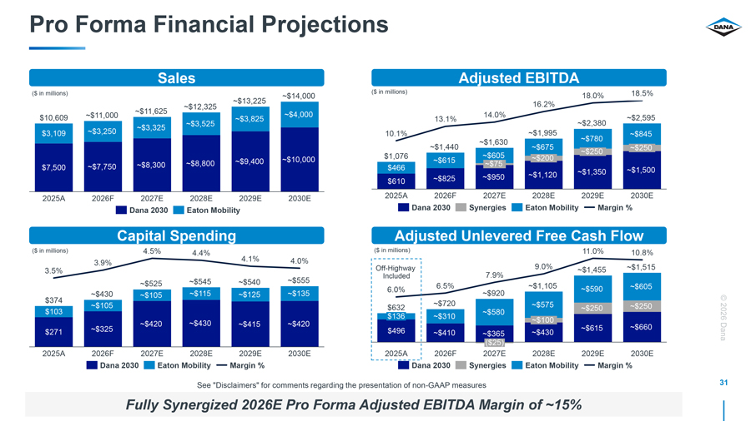
Pro Forma Financial Projections Sales Adjusted EBITDA ($ in millions) ($ in millions) 18.5% ~$14,000 18.0% ~$13,225 16.2% ~$12,325 ~$11,625 ~$4,000 14.0% $10,609 ~$11,000 ~$3,825 ~$2,595 13.1% ~$3,525 ~$2,380 ~$3,325 $3,109 ~$3,250 10.1% ~$1,995 ~$780 ~$845 ~$1,630 ~$1,440 ~$675 ~$250 ~$250 $1,076 ~$605 ~$200 ~$9,400 ~$10,000 ~$615 ~$7,750 ~$8,300 ~$8,800 ~$75 $7,500 $466 ~$1,500 ~$1,120 ~$1,350 ~$825 ~$950 $610 2025A 2026F 2027E 2028E 2029E 2030E 2025A 2026F 2027E 2028E 2029E 2030E Dana 2030 Eaton Mobility Dana 2030 Synergies Eaton Mobility Margin % Capital Spending Adjusted Unlevered Free Cash Flow ($ in millions) 4.5% 4.4% ($ in millions) 11.0% 10.8% 4.1% 4.0% 3.9% Off-Highway 9.0% ~$1,455 ~$1,515 3.5% Included 7.9% ~$525 ~$545 ~$540 ~$555 6.5% ~$1,105 ~$590 ~$605 6.0% ~$920 ~$430 ~$105 ~$115 ~$125 ~$135 $374© ~$105 ~$720 ~$575 ~$250 $632 ~$250 $103 ~$580 $136 ~$310 2026 ~$420 ~$430 ~$415 ~$420 ~$100 ~$660 ~$325 8.1% ~10.6% $496 ~$615 ~10.6% $271 ~$410 ~$365 ~$430 Margin Margin Margin Dana ($25) 2025A 2026F 2027E 2028E 2029E 2030E 2025A 2026F 2027E 2028E 2029E 2030E Dana 2030 Eaton Mobility Margin % Dana 2030 Synergies Eaton Mobility Margin % See “Disclaimers” for comments regarding the presentation of non-GAAP measures 31 Fully Synergized 2026E Pro Forma Adjusted EBITDA Margin of ~15%

