Filed by Dana Incorporated
Pursuant to Rule 425 under the Securities Act of 1933
and deemed filed pursuant to Rule 14a-12
under the Securities Exchange Act of 1934
Subject Company: Dana Incorporated
Commission File No.: 001-01063
Date: August 13, 2026
The following materials were presented by Dana Incorporated (“Dana”) at the J.P. Morgan Auto Conference on August 13, 2026, and include information regarding the proposed business combination between Dana and Mobility (USA) Corporation, a wholly owned subsidiary of Eaton Corporation plc.



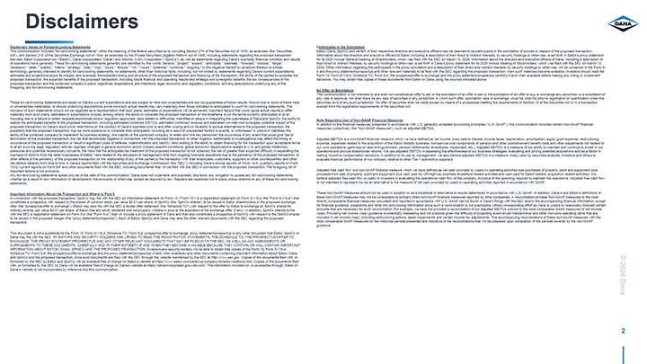

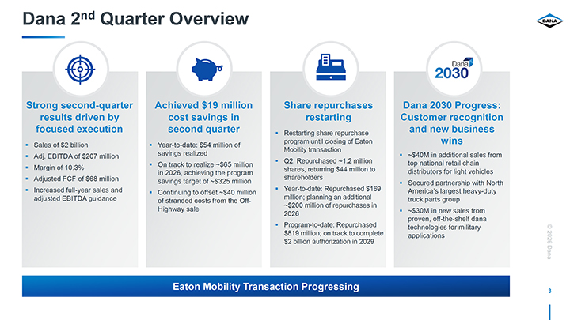

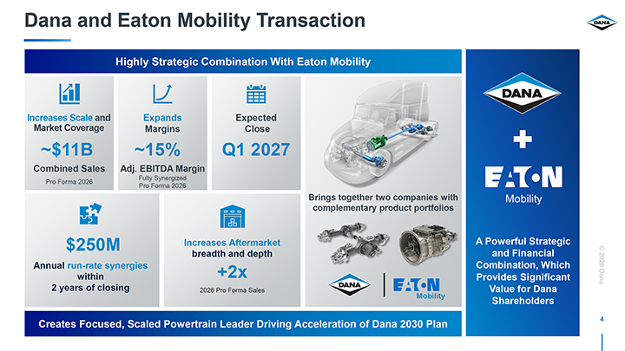

2

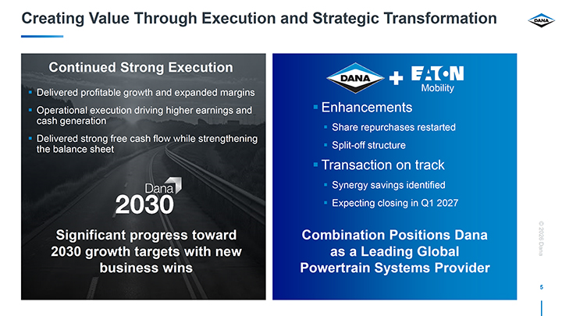

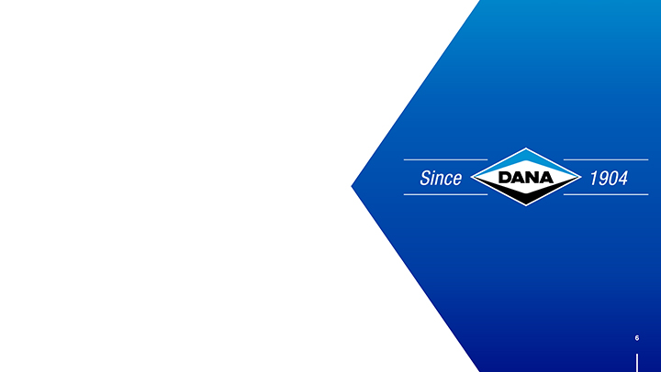

3

Cautionary Notes on Forward-Looking Statements
This communication includes “forward-looking statements” within the meaning of the federal securities laws, including Section 27A of the Securities Act of 1933, as amended (the “Securities Act”), and Section 21E of the Securities Exchange Act of 1934, as amended by the Private Securities Litigation Reform Act of 1995, including statements regarding the proposed transaction between Eaton Corporation plc (“Eaton”), Dana Incorporated (“Dana”) and Mobility (USA) Corporation (“SpinCo”), as well as statements regarding Dana’s business, financial condition and results of operations more generally. These forward-looking statements generally are identified by the words “believe,” “project,” “expect,” “anticipate,” “estimate,” “forecast,” “outlook,” “target,” “endeavor,” “seek,” “predict,” “intend,” “strategy,” “plan,” “may,” “could,” “should,” “will,” “would,” “potential,” “continue,” “ongoing,” or the negative thereof or variations thereon or similar terminology generally intended to identify forward-looking statements. All statements, other than historical facts, including, but not limited to, statements regarding Dana’s current expectations, estimates and projections about its industry and business, the expected timing and structure of the proposed transaction and financing of the transaction, the ability of the parties to complete the proposed transaction, the expected benefits of the proposed transaction, including future financial and operating results and strategic and synergistic benefits, the tax consequences of the proposed transaction and the combined company’s plans, objectives, expectations and intentions, legal, economic and regulatory conditions, and any assumptions underlying any of the foregoing, are forward-looking statements.
These forward-looking statements are based on Dana’s current expectations and are subject to risks and uncertainties and are not guarantees of future results. Should one or more of these risks or uncertainties materialize, or should underlying assumptions prove incorrect, actual results may vary materially from those indicated or anticipated by such forward-looking statements. The inclusion of such statements should not be regarded as a representation that such plans, estimates or expectations will be achieved. Important factors that could cause actual results to differ materially from such plans, estimates or expectations include, among others, the ability to complete the proposed transaction on the timeframe or on the terms currently anticipated or at all, including due to a failure to obtain requisite stockholder and/or regulatory approvals; risks related to difficulties, inabilities or delays in integrating the businesses of Dana and SpinCo; the ability to realize the anticipated benefits of the proposed transaction, including estimated combined EBITDA, estimated combined revenue and estimated run-rate cost synergies; potential impact of the proposed transaction on Dana’s stock price; restrictions on the conduct of Dana’s business prior to and after closing and on its ability to pursue alternatives to the proposed transaction; the possibility that the proposed transaction may be more expensive to complete than anticipated, including as a result of unexpected factors or events, or unforeseen or unknown liabilities; the ability of the combined company to implement its business strategy; the inability of the combined company to retain and hire key personnel; the occurrence of any event that could give rise to termination of the proposed transaction; the risk that stockholder litigation in connection with the proposed transaction or other litigation, settlements or investigations may affect the timing or occurrence of the proposed transaction or result in significant costs of defense, indemnification and liability; risks relating to the ability to obtain financing for the transaction upon acceptable terms or at all; evolving legal, regulatory and tax regimes; changes in general economic and/or industry specific conditions; global economic repercussions related to U.S. and global inflationary pressures and potential recessionary concerns; the risks that the anticipated tax treatment of the proposed transaction is not obtained; the risk of greater than expected difficulty in separating the business of SpinCo from the other businesses of Eaton; risks related to the disruption of management time from ongoing business operations due to the pendency of the proposed transaction, or other effects of the pendency of the proposed transaction on the relationship of any of the parties to the transaction with their employees, customers, suppliers or other counterparties; and other risk factors detailed from time to time in Dana’s reports filed with the Securities and Exchange Commission (the “SEC”), including Dana’s annual reports on Form 10-K, quarterly reports on Form 10-Q, current reports on Form 8-K and other documents filed with the SEC, including documents that will be filed with the SEC in connection with the proposed transaction. The foregoing list of important factors is not exclusive.
Any forward-looking statements speak only as of the date of this communication. Dana does not undertake, and expressly disclaims, any obligation to update any forward-looking statements, whether as a result of new information or development, future events or otherwise, except as required by law. Readers are cautioned not to place undue reliance on any of these forward-looking statements.

4

Important Information About the Transaction and Where to Find It
In connection with the proposed transaction, SpinCo may file with the SEC an information statement on Form 10 (“Form 10”) or a registration statement on Form S-1/S-4 (the “Form S-1/S-4”) that constitutes a prospectus with respect to the shares of common stock, par value $0.01 per share, of SpinCo (the “SpinCo shares”) to be issued to Eaton shareholders in the proposed exchange offer (the “prospectus/offer to exchange”). Eaton may also file with the SEC a tender offer statement (the “Schedule TO”) with respect to the offer by Eaton to exchange all SpinCo shares for ordinary shares, par value $0.01 per share, of Eaton that are validly tendered and not properly withdrawn prior to the expiration of the exchange offer (if any). In addition, SpinCo intends to file with the SEC a registration statement on Form S-4 (the “Form S-4”) that will include a proxy statement of Dana and that also constitutes a prospectus of SpinCo with respect to the SpinCo shares to be issued in the proposed merger (the “proxy statement/prospectus”). Each of Eaton, SpinCo and Dana may also file other relevant documents with the SEC regarding the proposed transaction.
This document is not a substitute for the Form 10, Form S-1/S-4, Schedule TO, Form S-4, prospectus/offer to exchange, proxy statement/prospectus or any other document that Eaton, SpinCo or Dana may file with the SEC. INVESTORS AND SECURITY HOLDERS ARE URGED TO READ THE REGISTRATION STATEMENTS, THE SCHEDULE TO; THE PROSPECTUS/OFFER TO EXCHANGE, THE PROXY STATEMENT/PROSPECTUS AND ANY OTHER RELEVANT DOCUMENTS THAT MAY BE FILED WITH THE SEC, AS WELL AS ANY AMENDMENTS OR SUPPLEMENTS TO THESE DOCUMENTS, CAREFULLY AND IN THEIR ENTIRETY IF AND WHEN THEY BECOME AVAILABLE BECAUSE THEY CONTAIN OR WILL CONTAIN IMPORTANT INFORMATION ABOUT EATON, DANA, SPINCO AND THE PROPOSED TRANSACTION. Investors and security holders will be able to obtain free copies of the Form 10, Form S-1/S-4, Schedule TO, Form S-4, the prospectus/offer to exchange and the proxy statement/prospectus (if and when available) and other documents containing important information about Eaton, Dana and SpinCo and the proposed transaction, once such documents are filed with the SEC through the website maintained by the SEC at http://www.sec.gov. Copies of the documents filed with, or furnished to, the SEC by Eaton and SpinCo will be available free of charge on Eaton’s website at https://www.eaton.com/us/en-us/company/investor-relations.html. Copies of the documents filed with, or furnished to, the SEC by Dana will be available free of charge on Dana’s website at https://danaincorporated.gcs-web.com/. The information included on, or accessible through, Eaton or Dana’s website is not incorporated by reference into this communication.
Participants in the Solicitation
Eaton, Dana, SpinCo and certain of their respective directors and executive officers may be deemed to be participants in the solicitation of proxies in respect of the proposed transaction. Information about the directors and executive officers of Eaton, including a description of their direct or indirect interests, by security holdings or otherwise, is set forth in Eaton’s proxy statement for its 2026 Annual General Meeting of Shareholders, which was filed with the SEC on March 13, 2026. Information about the directors and executive officers of Dana, including a description of their direct or indirect interests, by security holdings or otherwise, is set forth in Dana’s proxy statement for its 2026 Annual Meeting of Stockholders, which was filed with the SEC on March 13, 2026. Other information regarding the participants in the proxy solicitation and a description of their direct and indirect interests, by security holdings or otherwise, will be contained in the Form S-4 and the proxy statement/prospectus and other relevant materials to be filed with the SEC regarding the proposed transaction when such materials become available. Investors should read the Form 10, Form S-1/S-4, Schedule TO, Form S-4, the prospectus/offer to exchange and the proxy statement/prospectus carefully if and when available before making any voting or investment decisions. You may obtain free copies of these documents from Eaton or Dana using the sources indicated above.

5

No Offer or Solicitation
This communication is not intended to and shall not constitute an offer to sell or the solicitation of an offer to sell or the solicitation of an offer to buy or exchange any securities, or a solicitation of any vote or approval, nor shall there be any sale of securities in any jurisdiction in which such offer, solicitation, sale or exchange would be unlawful prior to registration or qualification under the securities laws of any such jurisdiction. No offer of securities shall be made except by means of a prospectus meeting the requirements of Section 10 of the Securities Act or in a transaction exempt from the registration requirements of the Securities Act.
Note Regarding Use of Non-GAAP Financial Measures
In addition to the financial measures presented in accordance with U.S. generally accepted accounting principles (“U.S. GAAP”), this communication includes certain non-GAAP financial measures (collectively, the “Non-GAAP Measures”), such as adjusted EBITDA.
Adjusted EBITDA is a non-GAAP financial measure which we have defined as net income (loss) before interest, income taxes, depreciation, amortization, equity grant expense, restructuring expense, expenses related to the acquisition of the Eaton Mobility business, non-service cost components of pension and other postretirement benefit costs and other adjustments not related to our core operations (gain/loss on debt extinguishment, pension settlements, divestitures, impairment, etc.). Adjusted EBITDA is a measure of our ability to maintain and continue to invest in our operations and provide shareholder returns. We use adjusted EBITDA in assessing the effectiveness of our business strategies, evaluating and pricing potential acquisitions and as a factor in making incentive compensation decisions. In addition to its use by management, we also believe adjusted EBITDA is a measure widely used by securities analysts, investors and others to evaluate financial performance of our company relative to other Tier 1 automotive suppliers.
Adjusted free cash flow is a non-GAAP financial measure which we have defined as net cash provided by (used in) operating activities less purchases of property, plant and equipment plus proceeds from sale of property, plant and equipment plus cash paid for Off-Highway business divestiture related activities and cash paid for Eaton Mobility acquisition related activities. We believe adjusted free cash flow is useful to investors in evaluating the operational cash flow of the company inclusive of the spending required to maintain the operations. Adjusted free cash flow is not intended to represent nor be an alternative to the measure of net cash provided by (used in) operating activities reported in accordance with GAAP.
These Non-GAAP Measures should not be used in isolation or as a substitute or alternative to results determined in accordance with U.S. GAAP. In addition, Dana’s and Eaton’s definitions of these Non-GAAP Measures may not be comparable to similarly titled non-GAAP financial measures reported by other companies. A reconciliation of these Non-GAAP Measures to the most directly comparable financial measures calculated and reported in accordance with U.S. GAAP can be found in Dana’s filings with the SEC and/or the accompanying financial information, except for financial guidance, projections and other forward-looking information since such a reconciliation is not practicable without unreasonable effort as Dana is unable to reasonably forecast certain amounts that are necessary for such reconciliation. For example, we have not provided a reconciliation of our adjusted EBITDA outlook to the most comparable GAAP measures of net income (loss). Providing net income (loss) guidance is potentially misleading and not practical given the difficulty of projecting event-driven transactional and other non-core operating items that are included in net income (loss), including restructuring actions, asset impairments and certain income tax adjustments. The accompanying reconciliations of these non-GAAP measures with the most comparable GAAP measures for the historical periods presented are indicative of the reconciliations that will be prepared upon completion of the periods covered by the non-GAAP guidance.

6

